**HARMONY BEHIND THE SCENES: ORGANIZERS' LIVED EXPERIENCES IN THE MUSIKAHAN FESTIVAL OF TAGUM CITY**

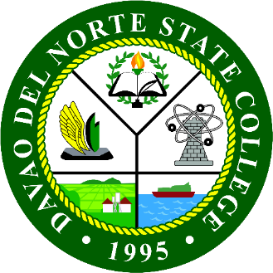

An Undergraduate Thesis

Presented to the Faculty Member of the

Institute of Leadership, Entrepreneurship and Good Governance

Davao del Norte State College

Panabo City

ALEXA REGINE M. ALFORQUE

SOFIA B. BOOC

MARY ELLINE D. ENALLIM

JOHN PAULO G. PAHAGAC

MARY ZHANE G. TORRECAMPO

December 2025

# INTRODUCTION

## Background of the Study

Every February, the streets of Tagum City become a spectacle filled with sound, movement, and culture, as the Musikahan Festival continues. The beat of drums can be heard in the public spaces, local bands compete on brightly lit stages, and people come together to celebrate their cultural identity and sense of place as the "Music Capital of the South," an identity that is closely related to the long history of the people of Tagum City for the practice of music and the institutionalization of Musikahan as the premier cultural festival in the area (Philippine Information Agency, 2021; City Government of Tagum, 2022). The Musikahan Festival is more than a spectacle, as it is a large cultural activity that brings together different artists and government institutions, thus creating cultural pride, which is likewise a complex activity that involves behind-the-scenes activities. The institutionalization of cultural festivals is a complex and arduous activity that involves much more than the mere coordination of events and audience engagement (Le, 2024).

While much of the existing festival and event research since 2020 still prioritizes economic impacts, tourism benefits, destination branding, and visitor satisfaction, such frameworks often eclipse deeper cultural, strategic, and experiential dimensions of festivals-that is, the lived experiences and decision-making processes of the organizers themselves. More precisely, contemporary tourism and festival studies have clearly revealed that while the economic and social impacts of festivals remain well recorded, there is a continuous stress on quantitative measures such as tourist motivations, satisfaction, loyalty, and perceived value, without paying due attention to qualitative inputs from organizers in respect to cultural meaning, challenges, and strategic agency regarding festival production.

Every year, within the month of February, the streets of Tagum City come alive as the Musikahan Festival is held. There is a cacophony of drumbeats, competing local bands performing on brightly lit stages, and people coming together for a celebration of the city’s identity as it is referred to as the “Music Capital of the South.” The distinction is officially sanctioned for Tagum, a city that has a tradition of music festival events and a cultural identification that is festival-centric. It is, beyond a festival, a vast and elaborate process involving artists, government agencies, and communities, which translates into creating cultural pride but also requires coordination that is complex. "The act of organizing a cultural festival is a complex and challenging process, and it is certainly not just a question of the management and engagement of the event and the audience." Naturally, a good deal of the current scholarly work on festivals and events post-2020 continues to stress the economic, tourism, branding, and satisfaction aspects of festivals. However, a glance at the recent and contemporary work in tourism and festivals leads to the conclusion that, in spite of the demonstrated economic and social effects of festivals, there is still a preference for the discussion of tourist motivation, satisfaction, and economic value, in addition to a lack of attention to the qualitative aspects of the festival organizers.

Organizers at festivals face a challenge of constantly balancing multiple imperatives, such as ensuring the authenticity of cultural activities despite the presence of commercial activities, promoting a culture of inclusivity among various stakeholders, as well as ensuring sustainability while at the same time taking into account environmental considerations. Authenticity in culture contributes to a culture of social sustainability as it helps to create a sense of identity, while at the same time requiring strategic planning as well as stakeholder management imperatives (Le, 2024). The incorporation of sustainability into environmental, social, and economic spheres also complicates event management, as the two imperatives require event planners to ensure inclusion, authenticity, as well as economic viability in order to improve stakeholder experience (Ismail et al., 2025). Notably, studies performed on event sustainability reveal that adopting sustainable practices might require the organizers to traverse financial and structural hurdles; therefore, the role of organizers is highly strategic rather than operational (Gonçalves et al., 2025). At the same time, formulating effective ways to ensure inclusivity for oft-marginalized communities presents another challenge for festival communication design (Irimiás, 2024). Therefore, the role of organizers is not only operational but also highly cultural and strategic.

In addition to its cultural vitality, the Musikahan Festival is also formally integrated into the local governance system of the city of Tagum. The incorporation of the Musikahan Festival into local governance is ensured through City Ordinance No. 911 of the Series of 2019, also referred to as the ‘Code of Festivals of Tagum City.’ By virtue of this ordinance, the Musikahan Festival is officially one of the city’s annual festivals, as recognized by the City Tourism Office and mandated for planning and implementation by the local government of Tagum City. The legal setting ensures that the Musikahan Festival is effective not just as a festival but also as a cultural preservation tool and a contributory factor to the formation of local identities.

The cultural festivals are very important mechanisms to ensure intangible cultural heritage, as the community is provided with a space for the transmission of collective memory, artistic expression, and customary practices across generations. This gives reason for their importance as living heritage-dynamic, evolving cultural processes that ensure community pride is advanced, shared identity reinforced, and cultural continuity promoted. Recent scholarship increasingly recognizes festivals as platforms for cultural diversity, intercultural dialogue, and heritage preservation, and points out their capacity to sustain cultural knowledge while adapting to contemporary social contexts (Eichler, 2020). In contemporary society, festivals have become tools of cultural sustainability that help communities balance tradition with modern economic and social demands and contribute to social cohesion and local development.

In the last few decades, cultural festivals have continued to change and adapt to emerging issues concerning global trends in the expansion of tourism, the commercialization of heritage, and sustainable development. New and innovative approaches in festivals, like the implementation of digital marketing approaches, the inclusion of more sponsors, and the integration of sustainable principles, have not only raised the profile and attendance of these festivals but also their economic benefits (Quinn et al., 2020). On the other hand, the developments have also heightened the apparent tensions or dilemmas between sustainability and cultural heritage, given the issues concerning the homogenization and commercialization of heritage. In the PH environment, a key challenge continues to be the delicate balancing act between heritage management and the promotion of tourism, particularly in the construction of a city or regional identity in the face of strong government and business interests (Marbun et al., 2025). Renowned festivals like Sinulog, Panagbenga, and Kadayawan are considered a representation of the ongoing balancing act between cultural heritage and the needs of the masses.

In the context of this wider picture, the Musikahan Festival in Tagum City has established itself as a noteworthy cultural and economic activity that celebrates the musical legacy of the host city and promotes it as a competitive site for cultural tourism (Alama, 2023). Festival organizers play a key mediating role between cultural and community values, government directives, sponsor requirements, and the wider audience. As sponsorship and tourism promotion provide crucial resources for the festival to thrive, they also carry a threat of cultural exploitation should they not be managed carefully. Besides this, cultural festival organizers also have to pay attention to issues of inclusivity to ensure equal regard for local cultural practitioners and minorities and to incorporate sustainability issues at the festival site with regard to waste disposal, environmental consequences, and resource use.

In spite of the perceived cultural and economic significance of festivals like Musikahan, extant literature has continued to primarily concentrate on its tourism and economic advantages, including its impact on the number of tourists, revenue generation, and brand building (Finkel & Platt, 2020). However, the real-life experiences of festival organizers—those directly engaged with issues of authenticity, inclusiveness, and sustainability—have continued to remain understudied within existing literature. This creates a hole in the understanding of the larger picture regarding festival governance without perceiving the motivations and limitations of organizers.

Addressing this gap, the present study foregrounds the lived experiences of the Musikahan Festival organizers to investigate how they interpret and respond to the various intersecting cultural, economic, and institutional pressures. By placing organizers' narratives at the forefront, this research explores how cultural leaders navigate competing concerns for heritage preservation and commercialization, inclusivity and pragmatic constraints, and sustainability with the imperatives of large-scale public events. In so doing, this research furthers an increasingly nuanced and culturally responsive understanding of festival management and provides theoretical and practical insights toward sustaining authentic, inclusive, and sustainable cultural festivals in Tagum City and similar cultural contexts.

This study also falls under the DNSC Research Agenda, particularly the Socio-Cultural Research thrust that promotes the documentation and sustainability of local culture and heritage. In addition, the study has relevance to the UN SDGs on SDG 8, Decent Work and Economic Growth, because it has something to do with cultural industries and festival labor, and SDG 11, Sustainable Cities and Communities, since cultural festivals inform about heritage conservation, social cohesion, and ensure more inclusive urban cultural development.

## Theoretical Framework

This study was guided by three theories: Freeman’s (1984) Stakeholder Theory, Homans’ (1958) Social Exchange Theory, and Soini and Birkeland’s (2014) Cultural Sustainability Theory, to analyze organizers’ experiences in the Musikahan Festival and provide a comprehensive view of its sustainability and comTmunity value.

On the other hand, the Stakeholder Theory maintains that a firm must create value to all individuals and groups that may influence and be influenced by its decisions and actions (Freeman, 1984). In the case of Musikahan Festival, these individuals and groups include the organizers, the performers, the city tourism office, government agencies, the sponsors, and the community. These individuals and groups have different levels of power, legitimacy, and urgency (Moreno-Mendoza et al., 2019). This theory assisted the researchers in identifying all the individuals and groups that constitute the Musikahan Festival.

Social Exchange Theory (Homans, 1958; Blau, 1964; Thibaut & Kelley, 1959) describes stakeholder engagement as weighing costs against benefits. Participation increases when cultural pride, social prestige, economic returns, and political support are greater than costs (Stafford & Kuiper, 2021; Zengeya et al., 2023). Participation was sustained as long as the rewards outweighed the burdens. The participants' motivation to organize was undergirded with personal achievement, self-improvement, cultural pride, and social appreciation, anchored in this theory.

Cultural Sustainability Theory (Soini & Birkeland, 2014) emphasizes festivals’ roles in terms of heritage, identity, and expression. Cultural events are essential in self-identification, enhancing a sense of belonging, and connecting the past and the present. Bandala (2020) proves that local festivals are essential constructs for sustainability, bringing both culture and environment into the picture. For Musikahan, the significance of the event lies beyond economic benefits; it finds meaning in terms of sustaining identity and a sense of pride through traditions, as emphasized by CST.

In general, it centers on the study of organizational structure, motivational aspects, and cultural dimensions that affect the lived experiences of the organizers. Stakeholder Theory describes who matters and how in the festival organization. Meanwhile, Social Exchange Theory explains why organizers engage and continue to do so despite challenges. Cultural Sustainability Theory points out what was sustained, preserved, and transmitted as part of sustainable development. Put together, these approaches allowed the research into the lived experiences of the Musikahan Festival organizers.

**Research Questions**

This section outlined the research questions that guided the researcher in developing the interview guide questionnaire.

1. What are the lived experiences of the organizers of the Musikahan Festival in Tagum City, particularly in relation to authenticity, inclusivity, and sustainability?
2. What strategies do the organizers implement to manage the Musikahan Festival in Tagum City?
3. What insights have the organizers gained from their involvement, and what recommendations do they propose for enhancing operational harmony and long-term sustainability?

## Statement of the Problem

This study aimed to fill the information gap related to the experiences of the organizers of the Musikahan Festival in Tagum City. While the festival has been of great significance in fostering culture, music, and tourism in Tagum City, the lived experiences and perspectives of the organizers of the Musikahan Festival, who worked backstage to take the festival into realization, remained underexplored, with most written pieces about the Musikahan Festival being related to its tourism and economic contributions.

The research problem under consideration emanated from the need to understand the ways used by the organizers in managing the festival, striking a balance between traditional and new developments, and overcoming challenges such as resource availability, weather conditions, stakeholder interests, and the changing needs of the people within the community. Their insights and recommendations were also valuable, but yet to be captured by any research study.

It is for this reason that this study found the significance of its purpose in presenting the lived experiences of the organizers, the ways in which the organizers navigated the Musikahan Festival, and the lessons and recommendations of the organizers in its involvement in the Musikahan Festival. This study provided an understanding of the culture surrounding the success and sustainability of the Musikahan Festival.

# METHODOLOGY

This chapter presents the major components that guided the study. It described the research design, explained the participant selection process, introduced the research setting, and outlined the research instruments used during data collection. It also discussed the steps taken in data collection, presented the ethical considerations encountered, and explained the procedures used to analyze the qualitative data.

## Design

The research design used by the authors of this study was descriptive phenomenological research that utilized a philosophical approach based on the understanding of Husserl. It sought to investigate the experiences of the organizers of the Musikahan Festival with regard to the planning, implementation, and promotion of their event, with particular emphasis on authenticity, inclusiveness, and sustainability concerns.

The researchers, according to the phenomenological approach, were guided by the epoché or bracketing of Husserl, which involved making an effort to set aside their assumptions and focus on the descriptions of the research participants’ experiences (Husserl, 2012; Abraham & Padmakumari, 2025). The researchers were aware of their positionality in relation to the study. They were exposed to academic settings about event planning, which helped them understand the context of festival organization. Although there is a possibility that the researchers' academic experience would affect their assumptions, the phenomenological approach helped the researchers obtain the research outcomes through lived experiences, rather than depending on the researchers' own assumptions.

This design was suitable for this study because it helped to gain a deeper understanding of the perspectives and experiences of the organizers on Musikahan Festival. This design was also useful because it enabled the gaining of insights that could not be adequately obtained through quantitative approaches.

## Participants

These participants, on the other hand, used purposive sampling, which is considered a non-probability sampling method that aims to include individuals with valuable knowledge and direct experiences related to specific topics (Campbell et al., 2020). This helped to generate deeper insights on aspects related to planning, management, and promotion, which brought value to the study's focus on institutions, organizations, and decision-making.

A total of five (5) key informants took part in this research. Though this sample proved adequate in terms of depth of understanding, it also highlighted that this was a relatively small and homogeneous group, as all were working within the same government institution. The last few methodological research studies highlighted that when doing qualitative-based research, and focusing more on depth, key findings, and overall thematic saturation, rather than looking at a wide sample, purposive-based, or very small sampling, ranging from approximately five (5) to seventeen (17) participants, was permissible (Campbell et al., 2021; Guest, Namey, & Chen, 2020). However, when looking at a very small sample, such as this, and that was also homogeneous, it has to be factored in that this could limit the overall sample group (Wutich, Beresford, & Bernard, 2024).

The inclusion criteria emphasized individuals, particularly those at managerial or leadership positions, directly involved in the processes of festival decisions, programming, and/or promotion, having a minimum of at least 3 years of uninterrupted participation in the Musikahan Festival. Also, respondents addressed the need to have possessed a certain level of authority through their responsibilities in the processes of festival implementation. While this reinforced the research’s emphasis on institutions, it may have, in turn, limited the research to a certain extent specifically to the official story, possibly failing to capture alternative readings of authenticity, inclusivity, and sustainability from different stakeholders. It is expected that in further research, consideration should be given to more inclusive sampling criteria, such as the inclusion of independent cultural workers, artists, coordinators at barangay levels, volunteers, etc.

Even though this particular participant selection enhanced the focus of the study on institutional viewpoints, it remains nevertheless as one of the limitations of this investigation. For one, the sole participation of Tourism Office personnel might have brought some level of constraint to the results in terms of narratives and viewpoints on governance only; the possibility of discovering varying viewpoints on authenticity, inclusivity, and sustainability might have remained unexplored in this study. It would therefore be greatly appreciated and encouraged in future studies to take on a more expansive approach in this aspect by making use of independent cultural workers, artists, barangay-level coordinators, and so on, allowing a more diverse and varied array of life experiences to become part of the analysis of festival governance and ultimately of the broader concept of cultural festivals in general, like Musikahan.

## Locale

The research was empirically carried out in Tagum City, Davao del Norte, which is designated as the official host of the Musikahan Festival. Tagum City is known as one of the fastest-growing cities in Mindanao and boasts of being branded as the “Music Capital of the South” in recognition of its significant cultural undertakings and pursuits of its cultural interests in promoting and encouraging music and art. The Musikahan Festival, being one of this city’s flagship events, is annually celebrated and intended to promote and exhibit its unique musical traditions, talents, and creative expressions that distinguish it as a cultural hub in the Davao Region.

Significantly, the city was identified as the “Music Capital of the South” with a pre-established reputation that created a worthy context in which to examine the realities of festival organizers. The relevance of conducting research in Tagum was further emphasized by the initiatives of the city government, including City Ordinance No. 911, Series of 2019, or the Code of Festivals of Tagum City, which institutionalized the Musikahan Festival, among others, as yearly events in the city. The City Tourism Office actively contributed to the conceptualization, promotion, and implementation of the Musikahan Festival, in which it can be seen as a context in pursuing a similar vision.

In general, therefore, it can be determined that Tagum City was a highly suitable context for this particular research. In point of fact, aside from the active cultural ambiance, it must be noted that the context was particularly considerable in terms of its contribution to the furtherance of tourism development, participation, and sustainability in culture. With a focus in context, as such, the research in Tagum City highlighted the in-depth lived experiences of festival organizers, which created a contribution to further academic discussions.

## Instruments

It also utilized a semi-structured interview guide prepared by the researcher as the main instrument for this study to gather in-depth, qualitative data on the lived experiences of the Musikahan Festival organizers in Tagum City. The instrument was developed in accordance with the objectives of the present study and focused on organizers' experiences in terms of authenticity, inclusivity, sustainability, and management practices adopted in the festival.

The interview guide contained 15 main questions, with follow-up and probing questions to prompt further elaboration by the participants. Questions were open-ended in nature to allow detailed narratives and personal reflections relevant to the focus of the research. The full set of interview guide questions is included in Annex E.

In order to ensure the validity of the instrument, the interview guide was validated by three (3) experts in research and event management through content validation. This ensured the relevance and appropriateness of the instrument to the research objectives. Following the validation process, the research instrument got a rating of “Very Good” since the questions were appropriate for data collection.

Before data collection, some minor changes suggested by the validators were incorporated to enhance the readability of the questions and their logical flow. The validated interview guide has been used uniformly in all interviews to ensure the reliability of the data collected.

**Data Collection Procedure**

For one, the gathering of data to be used for this research undertook a qualitative approach wherein selected key informants were chosen through the use of a number of semi-structured interviews. This methodology is advantageous and effective because it allows room for flexibility without losing focus entirely (Kallio et al., 2016). By conducting these interviews, the researcher reached a comprehensive understanding of the organization of the Musikahan festival and its effectiveness in promoting tourism.

The interviews will be conducted at a date and time based on the participant’s convenience. The interviews will also be conducted by face-to-face communication or through virtual means of communication. Before the interview process begins, the participant will be made aware of the research purposes and will also be assured of confidentiality. The participant will also be asked for their consent to record the interview through audio means for accurate data collection purposes. In addition to the above ways of increasing the reliability of the research process, field notes will be taken to facilitate a deeper understanding of the research process based on Merriam & Tisdell (2016).

The interview guide consisted of open-ended questions pertaining to the planning process, promotional techniques, cooperation from stakeholders, challenges faced, and the impact of the event. The researcher ensured that a neutral position was maintained to refrain from affecting the participants' responses. This ensured that the collected data accurately reflected the genuine views of the participants. According to Braun & Clarke (2019), this helped the participants to voicing their views in an open manner, aligned with the research objectives.

Each interview was conducted for approximately 45-60 minutes. The researchers took an unbiased stance and encouraged all participants to share their experiences freely in order to ensure that the data was accurately represented.

After collecting the data, all interviews were transcribed, and it was organized to be analyzed using qualitative methods. The collected data was coded, categorized, and grouped based on emerging themes, which corresponded with the needs of this particular study. Member checking, which also increased trustworthiness, was done to allow the participants to cross-check the collected data with their correct and accurate content (Lincoln and Guba, 1985).

## Data Analysis

The qualitative data from the semi-structured, in-depth interviews were analyzed using Braun and Clarke’s (2006) six-phase thematic analysis. This approach enables us to identify and analyze patterns of meaning in participants' lives systematically. The analysis followed these six steps:

Step 1: Familiarizing with the data – Interview recordings were transcribed verbatim and repeatedly reviewed alongside field notes to achieve immersion and familiarity with the dataset.

Step 2: Coding – Familiarization was followed by the identification and coding of meaningful parts of the data in all transcripts relevant to the research questions. To enable the researchers to reflect on the most important ideas, experiences, and views articulated by the participants.

Step 3: Generating initial themes – Related codes were grouped into initial themes that reflected shared patterns of meaning across the data.

Step 4: Reviewing themes – The original themes were reconsidered and refined by assessing their consistency with the coded data and the overall sample.

Step 5: Refining, defining, and naming themes – After the finalization of the themes, each was defined and named descriptively to represent its meaning. Subthemes and core ideas were identified to clarify the themes, and the refined themes were presented in thematic tables in the Findings chapter.

Step 6: Writing up - The themes were reported in the Findings and Discussion chapters in narrative form, with direct quotations from participants and interpretations in relation to the corresponding literature and theoretical frameworks.

This methodology enabled researchers to arrange data systematically and grasp shared patterns of meanings pertinent to research queries. Braun & Clarke's (2006) thematic analysis method was utilized due to its suitability and conformity with research objectives, since Braun & Clarke's method enabled researchers to grasp and comprehend the lived experiences of Musikahan Festival organizers in a clear manner. The research methodology facilitated researchers to grasp shared experiences, thoughts, and ideas among participants. The steps followed enabled researchers to link interview data systematically with research queries. The thematic analysis method enabled researchers to present data or research findings in line with quotations, ideas, and thoughts shared among participants, showcasing real-time experiences related to promoting authenticity, inclusivity, and sustainability.

## Ethical Consideration

Ethical considerations, on one hand, have been adhered to with great consideration in the entire handling of this research to ensure that every human subject was treated with respect, dignity, and equality. Prior to the administration of each interview, every subject was made aware of the intention and nature of the research, as well as their right to withdraw at any given point without any untoward consequence.

The issue of confidentiality was promoted by omitting names as well as any identifying information from all transcripts as well as the final manuscript. Codes were used in replacing the names of the participants, and all the recordings, transcripts, as well as documents, were stored in a confidential manner for academic use. Such confidentiality was in line with the concerns of participants in regard to their behind-the-scenes production, which was another theme that was echoed within the findings.

Throughout the process, the authors ensured that they are reflexive to eliminate bias in their approach; at the same time, they sought the authenticity of the stories that the festival organizers wanted to share with the world. This way, the researchers were able to live up to the aim of portraying their stories faithfully, especially in terms of cultural stewardship.

# FINDINGS AND DISCUSSION

This chapter presents findings from in-depth interviews with five organizers of the Musikahan Festival in Tagum City. To ensure confidentiality and protect participants’ identities, pseudonyms were assigned and used throughout the presentation of the results. The interview data were analyzed using thematic analysis to identify recurring patterns and significant themes that capture the organizers’ lived experiences regarding authenticity, inclusivity, sustainability, and the strategies they employ to ensure the festival’s success. The emergent themes highlight how organizers negotiate the preservation of cultural heritage alongside contemporary demands, manage stakeholder relationships, and address the operational and logistical challenges inherent in staging a large-scale cultural event.

**Table 1.**

*Participants Information*

|  |  |  |  |
| --- | --- | --- | --- |
| **Participants** | **Gender** | **Position/Designation** | **Length of Service/Experience** |
| Caroline | Female | Admin Assistant II | 3.5 years |
| Chelsea | Female | Tourism Operations Officer II | 10 years |
| Ken | Male | Admin Assistant | 12 years |
| Stacey | Female | Development Management  Officer II | 10 years |
| Liam | Male | Supervising Officer IV | 10 years |

# THE LIVED EXPERIENCES OF THE ORGANIZERS OF THE MUSIKAHAN FESTIVAL IN TAGUM CITY, PARTICULARLY IN RELATION TO AUTHENTICITY, INCLUSIVITY, AND SUSTAINABILITY

Table 2 focuses on the lived experiences of the organizers of the musikahan festival in Tagum City, particularly with respect to authenticity, inclusivity, and sustainability. It has four emergent themes: highlighting the festival’s role in cultural preservation, the balance between tradition and innovation, the importance of inclusivity, and the need for long-term sustainability to ensure its continued success.

**Table 2.** *The Lived Experiences of the Organizers of the Musikahan Festival in Tagum City, Particularly in Relation to Authenticity, Inclusivity, and Sustainability.*

|  |  |
| --- | --- |
| **EMERGING THEMES** | **CORE IDEAS** |
| **SAFEGUARDING CULTURAL IDENTITY THROUGH MUSIC** | Intentional preservation of traditional Filipino and Indigenous (IP) music |
| Music as an expression of cultural identity |
| Sustaining cultural traditions across generations |
| **BALANCING**  **TRADITION AND**  **MODERNITY**  **TO PRESERVE**  **AUTHENTICITY** | Modernization is embraced, but must not overshadow traditional culture. |
| Authenticity is maintained by retaining traditional  musical elements. |
| Innovation is welcome only when culturally respectful |

|  |  |
| --- | --- |
| **ADVANCING INCLUSIVITY THROUGH OPENNESS AND REPRESENTATION** | Musikahan welcomes participants of all ages, backgrounds, and cultures. |
| The festival serves as a meeting point for diverse artistic identities. |
| Inclusivity enhances engagement and broadens representation |

### Theme 1.1. Safeguarding Cultural Identity Through Music

### The Musikahan Festival is extremely important and has bearing on the preservation and sustenance of Filipino and/or Indigenous (IP) musical heritage while, at the same time, promoting and developing cultural identity. The Musikahan Festival is specially constructed so that it provides cultural entertainment, but it also has embedded within it a component pertaining to cultural preservation. Traditional forms of music have been incorporated, and this provides a boost to the relevance and importance of heritage in modern times. The cultural identity has been incorporated and regarded as a vital component of the overall reason and purpose of the Musikahan Festival. This provides impetus to the sustenance and development of local and Indigenous cultures.

Organizers emphasized that cultural preservation is a deliberate goal of the festival, particularly in showcasing traditional Filipino and IP music. Caroline explained that traditional musical forms are actively preserved and enhanced to ensure they are not lost and can be appreciated by future generations:

### 

## *“*Gina preserve jud namo ginahatagan jud ug bili… ang traditional Filipino music like ang Rondalla mao na siya ang gina preserve jud ug mas ginapa improve pa para dili siya mawala ug ma appreciate pa sa mga next generation.” (IDI– 01)

Chelsea highlighted that Musikahan provides a space where authenticity and identity are expressed through Indigenous music:

## “Through sa musikahan mapakita ang authenticity ug identity sa Filipino music and IP music.”. (IDI–02)

Additionally, efforts to sustain less popular traditional forms were noted, particularly in supporting brass bands and Drum and Lyre Corps (DVLC), despite declining mainstream interest. Liam expressed that:

## “Ginahatagan jud natug importansya ang brass band and DVLC, para mag luntad pa siya in the next generation.”. (IDI–05)

These accounts show that the Musikahan Festival operates beyond entertainment; it is a well-structured mechanism for cultural safeguarding. Traditional and Indigenous music, as symbols of collective identity, are consciously put forward, supported, and made to continuously exist with relevance in the evolving musical landscape. On the institutionalization of these traditional performances, organizers allow there to be an intergenerational transmission of culture, with the festival exposing its younger audiences to heritage music through active participation and observation. The less popular forms, like DVLC, are intentionally continued-a commitment to cultural sustainability even when such traditions are no longer commercially at the top. Furthermore, the approach of the organizers reflects awareness that cultural preservation has to be done with adaptation. Modern tools are strategically used to increase reach while maintaining authenticity, thus allowing tradition and innovation to coexist without lessening cultural integrity.

### The findings are consistent with the theory of Cultural Sustainability, which posits that cultural practices are sustained through adaptive continuity rather than preservation (Soini & Dessein, 2016). The MOVE Organization’s intention to preserve traditional music, as well as IP music, through its utilization of modern technology is consistent with cultural sustainability. The findings of the study are also consistent with the UNESCO framework for intangible cultural heritage, which posits that cultural heritage is a living tradition shared through community participation (Intangible Cultural Heritage Framework, 2018). Musikahan is a platform for community participation as it provides a platform where various cultural practices are enjoyed, promoted, and sustained. The findings of the research are also consistent with the Heritage Preservation Theory, which posits that festivals are cultural sites that promote identity, collective memory, and a sense of belonging (Smith, 2016). In promoting traditional music, Musikahan provides a platform for Tagum city’s identity as the “Music Capital of the South”.

### Theme 1.2. Balancing Tradition and Modernity to Preserve Authenticity

Organizers of the Musikahan Festival have identified the challenge of modernization without losing its cultural authenticity. Despite the advantages of new technologies, the organizers hold the view that innovation should never be achieved at the expense of losing some of the traditional culture involved in the festival. The concept of authenticity entails meeting the festival's cultural identity and needs of the current realities. The aspect of modernization acts as an enabler but is not considered unique in the festival process.

Across interviews, organizers consistently discussed the need to integrate modern tools while safeguarding tradition. Several participants cited social media as an effective means of expanding the festival’s reach. Others emphasized that modernization must be carefully regulated to avoid cultural dilution. Participants repeatedly stressed that both traditional and modern elements should be respected. These responses reflect a shared understanding of balance rather than an opposition between the old and the new. Liam explained:

## “We align them in a way where no one is stepped on or left behind, and at the same time, both the old and the new are recognized.” (IDI–05)

Caroline added:

## “We can always adapt and take advantage of what modernization offers in order to further promote the authenticity and the culture we want to improve or instill.” (IDI–01)

Based on the perspectives of the organizers, it is clear that they have a reflective and value-based approach to the management of culture. Their choice to use modern tools in the management of the festival does not mean they do not appreciate the importance of modernization because this approach guarantees that culture is given prominence despite its growing popularity. The use of technology does not alter the nature of the culture. The festival organizers are gatekeepers who control the use of innovation in the festival. This guarantees its authenticity and modernity.

This knowledge also resonates with the Cultural Sustainability Theory by Soini & Birkeland (2014), which actually supports the idea of ‘adaptive continuity’ rather than ‘cultural preservation’on its own. In addition, there’s also the view by Richards (2018) that innovation within festivals actually assists with the sustenance of authenticity when it’s underpinned by the values of heritage. Freeman's (1984) Stakeholder Theory also fits well; this acknowledges the need to balance the interests of traditionalists with modern-day festival-goers.

### Theme 1.3. Advancing Inclusivity through Openness and

### Representation

Inclusivity is a defining characteristic of the Musikahan Festival and is closely linked to its cultural authenticity. Organizers view representation as essential to accurately reflecting Tagum City’s diverse identity. They believe that cultural diversity enhances the festival’s meaning rather than weakening it. Openness allows multiple cultural narratives to coexist within the celebration. Inclusivity is therefore practiced as an active commitment rather than a symbolic gesture. This approach ensures that the festival represents the broader community.

Organizers consistently highlighted the festival’s openness to participants from various backgrounds. Several participants emphasized that competitions were open to performers beyond Tagum City. Others pointed to the inclusion of Indigenous Peoples and remote communities as central to the festival’s identity. Organizers noted that wider participation strengthened cultural visibility and recognition. These shared responses indicate a collective commitment to representation. Caroline stated:

## “There are competitions not only for Tagum. They are open to cities and municipalities across the Philippines.” (IDI–01)

Chelsea added:

## “We have IPs and tribes—so that’s where our authenticity comes from. Through festivals, not only in Musikahan, but we also showcase our tribes and identity.” (IDI–02)

Liam described the festival as a cultural convergence space:

## “It’s easier to identify Tagum now because everyone is involved. Even those in remote mountainous barangays can now showcase their culture because they are involved. The cultural aspect is further enhanced and more widely recognized because everyone is participating.” (IDI–05)

The above narratives point out that inculcation of inclusivity is emphasized at the operational levels of the festival. This is evident in that representation gives marginalized groups an opportunity to express their cultural identity. Therefore, it instills a sense of unity among the participants, considering that inclusivity is often emphasized within a cultural context. Culturally, inclusivity is an attribute of preservation, considering its emphasis in organizing a cultural event. Therefore, the festival is a community expression of shared cultural identity.

This is consistent with Freeman's (1984) Stakeholder Theory, which is centered on inclusivity in decision-making. This is also supported by Social Exchange Theory as discussed in Homans (1958), where engagement leads to mutual trust and ownership. The idea of cultural sustainability through its representation and diversity is also supported by Soini and Birkeland's (2014) Cultural Sustainability Theory. The inclusivity observed at the festival is indicative of modern perspectives on sustainable cultural events.

# STRATEGIC MANAGEMENT AND COPING MECHANISMS

Table 3 focused on the strategies the organizers implement to manage the musikahan festival in Tagum City. It has three emergent themes: the critical operational strategies employed by the organizers to ensure the festival’s success

**Table 3.** *The Strategies the Organizers Implement to Manage the Musikahan Festival in Tagum City.*

|  |  |
| --- | --- |
| **EMERGING THEMES** | **CORE IDEAS** |
| **SYSTEM-BASED PLANNING AND LOGISTICS MANAGEMENT** | Early preparation and structured planning |
| Clear division of roles and focal persons |
| Scheduling, venue management, and resource allocation |
| **TRANSPARENT AND TRUST- BASED STAKEHOLDER RELATIONS** | Clear communication with sponsors and partners |
| Transparency in limitations and expectations |
| Trust-building through professionalism |
| **COLLECTIVE EFFORT AND ADAPTIVE TEAMWORK** | Cooperation across teams and categories |
| Flexibility during unexpected issues |
| Shared responsibility during the event |

### Theme 2.1. Systems-Based Planning and Logistics Organization

Organizers reported that meticulous planning begins months in advance, with clear roles and responsibilities assigned to ensure smooth execution. They emphasized that proper delegation and pre-event coordination minimize last-minute complications and help the festival stay on schedule. Chelsea mentioned:

## “As early as October, we start planning so that things do not become chaotic when the event comes. Musikahan happens every February to March. The year before that—like this December, or even as early as October— we already start planning.” (IDI–02)

## According to the organizers, the successful management of the festival depends on assigning focal people to oversee each area. Liam stated:

## “The preparation that the team does involves assigning proper tasks to the right people according to where they fit. We select the person most suitable for the task, whether they are inclined or skilled in that area. Proper tasking and proper delegation of tasks are done, so the work is divided among different people.” (IDI–05)

Stacey added that the organizers also coordinate logistics to prevent overlaps and avoid last-minute changes:

## “Also, the plan to ensure smooth implementation is that you already know what you need to do next. And then, the logistics they need are already prepared so that when the actual event day comes, everything will not be chaotic. And everything will be ready when you have the plan.” (IDI–04)

The successful execution of the festival is only achieved through a meticulous approach towards its planning and organization. By allocating tasks and making provisions for the required logistics, the festival is able to avoid any problems that could potentially arise because of a lack of organization. Also, the organization of various functions associated with the festival is an efficient way of ensuring its success. Furthermore, task delegation is helpful in successfully managing large events, thus improving their performance. Also, planning is a key step for the success of the festival.

This strategy is also in conformity with the principles of event management outlined by Getz (2016). According to these principles, planning and role delegation are integral components of effective management. This strategy is also in conformity with the Cultural Sustainability Theory proposed by Soini and Birkeland (2014). This is so because proper organization and management of resources ensure the sustainability of the festival as a well-executed cultural event in the coming years.

### Theme 2.2. Transparent and Trust-Based Stakeholder Relations

A major strategy emphasized by the organizers is the creation of trust-based relationships with their stakeholders, including sponsors, performers, and suppliers. Organizers recognized that transparent communication is vital to ensure that everyone involved in the festival is aligned. For sponsors, it is important to explain clearly what their contributions will support and how those resources will be utilized.

Caroline shared:

## “Just be transparent. Explain to them what the Musikahan Festival is about and what they are expected to do, so they are aware of the purpose and their roles. For stakeholders, especially sponsors and local officials, there are designated staff to assist them, so you just need to be transparent.” (IDI–01)

Liam emphasized that this transparent approach also extends to the artists and performers, who need to be fully aware of their roles and responsibilities:

## “During our meetings with them, we ensure that our vision is aligned with theirs. Our goals must align with those of our sponsors and artists. They must share the same objectives to ensure balance. If our targets are different, if our mission does not align, and if we don’t include them in our activities and mission, the direction becomes opposite and different, and we cannot maintain a good relationship.” (IDI–05)

Maintaining transparent communications is very vital in developing and fostering wholesome and successful relationships with all stakeholders involved. As a result, it helps in creating an environment where all participants clearly understand their various roles and the general aim of the festival. The participants involved will get along well, as they have been well enlightened about the various roles expected of them and their general intentions, as espoused through transparency. This leads to cooperation among all participants, as everyone feels valued and understands that they have one general objective in common. It helps in fostering successful and long-lasting partnerships, which is very useful in maintaining the support that keeps the festival running. It also helps in managing expectations and hence evading possible conflicts.

This theme is strongly supported by Freeman’s (1984) Stakeholder Theory, which emphasizes the importance of clear communication in building trust and fostering positive relationships among all parties involved. Homans’ (1958) Social Exchange Theory also applies, as transparent communication fosters reciprocal relationships in which both organizers and stakeholders derive mutual benefits. This transparent approach helps the festival strengthen its network and build lasting partnerships that ensure its success.

**Theme 2.3. *Collective Effort and Adaptive Teamwork***

One of the most important aspects of organizing a large-scale event such as Musikahan is teamwork. Organizers frequently noted that successful festivals depend on cooperation and shared responsibility across various teams and categories. From venue setup to managing performances, each team plays a crucial role in the event’s success. Chelsea emphasized that, during the event, teamwork is key:

## “During the actual event. We support one another in making the event successful because each of us has an assigned role. If you are a focal person, you are not the only one handling your event — your colleagues also support and assist you.” (IDI–02)

While most organizers described teamwork and systematic planning as effective, Liam acknowledged that operational delays and internal tensions occasionally challenged coordination:

## “Sometimes conflicts arise, which prevent issues from being addressed because you can’t approach each other when there’s tension. Even if everyone has a role, when communication breaks down, it affects how fast problems are solved.” (IDI–05)

This dissident case illustrates that even with deliberate planning, people-related issues could interfere with process flow in critical situations. The example emphasizes the importance of process harmony not being taken for granted but being constantly subject to negotiation in terms of communication and relationship management. The negative case serves to increase the validity of the results because it shows that the organizers face challenges and successes alike.

The success of this festival lies greatly with teamwork and flexibility. From the answers, it is clear that teamwork is vital in handling the different challenges that may occur during the festival. For example, through teamwork, it is possible to solve any conflicts that may occur during the festival, thus allowing it to run smoothly. In this way, there is a great work environment where everyone is contributing to the success of the festival. Furthermore, it can be noted that the festival is adaptable, which makes it possible to be successful even in uncertain situations.

This theme aligns with Arcodia and Whitford’s (2018) emphasis on teamwork in ensuring the resilience of festivals. Cheung et al. (2019) also highlight the importance of flexibility and cooperation in large-scale events, ensuring smooth event execution despite challenges. This collective effort ensures the festival's success and sustainability despite operational disruptions.

# INSTITUTIONAL INSIGHTS AND SUSTAINABILITY PATHWAYS

Table 4 outlines the insights the organizers have gained and the recommendations they propose for enhancing operational harmony and sustainability. It has three emergent themes that highlight key insights from the organizers’ experience, emphasizing the personal, operational, and sustainability aspects of the festival.

**Table 4.** *The Insights of the Organizers have been gained, and the Recommendations they propose for Enhancing Operational Harmony.*

|  |  |
| --- | --- |
| **EMERGING THEMES** | **CORE IDEAS** |
| **PERSONAL AND PROFESSIONAL GROWTH THROUGH LIVED EXPERIENCE** | Skill development in communication, leadership, and time management |
| Increased self-confidence and professional expertise |
| Enhanced appreciation of Tagum’s culture and traditions |
| **THREATS TO CONTINUITY AND NEED FOR INSTITUTIONAL SUPPORT** | Political turnover affects program continuity |
| Financial limitations restrict the scale and quality of events |
| Preservation of traditional music is at risk without continued support |
| **YOUTH EMPOWERMENT AND TECHNOLOGICAL INTEGRATION** | Digital tools improve coordination and communication |
| Youth involvement is essential for the festival’s future success |
| Technology broadens the festival’s reach and visibility |

### Theme 3.1. Personal and Professional Growth Through Lived Experience

Organizers reported personal and professional growth as a key outcome of their involvement in the festival. Many participants reported that their involvement in organizing the festival helped them develop essential skills in areas such as leadership, time management, and communication. Ken shared:

## “In organizing, you really can't do it alone, so you need teammates, people who will be involved with you. For the first tasks, you provide instructions and implement rules for everyone involved in the event, ensuring they are properly communicated. At the same time, it’s important to handle them well. Essentially, you should aim to be friendly with them, close to them. You really need to have a good relationship with your colleagues because they’re the ones who will help you.” (IDI–03)

In addition to personal growth, participants also highlighted the professional skills they developed through their involvement. Chelsea shared:

## Proper coordination facilitates mutual understanding in the workplace; people help one another when coordination and communication are effective. When roles are designated, everyone moves into action and takes ownership—they have a sense of responsibility for their tasks because they are responsible for them. You also develop decision-making skills: as a focal person, you must think through what to do and choose the best ways to ensure the event's success. This helps you develop as an event organizer and as a person

**— you become more organized in decision-making and more mature. Those skills can also be applied to your everyday life. (IDI–02)**

Another key aspect of the organizers’ experience is their increased appreciation for Tagum’s culture. Liam reflected on how being involved in the festival deepened their respect for the city’s traditions:

## “Even if you have many experiences where your plans don’t go as expected, or you get confused about where to go next, and you encounter a lot of negativities, you still have to love your work. It’s not just for now, but for the future. Commitment is the most important because you won’t always love your work. You can’t love your work all the time, but because you are committed, you have to love it.” (IDI–05)

The role played by the organizers in the festival has been instrumental in bringing about personal and professional development. This is mainly through the acquisition of key skills that are useful in the process. These skills would help them in handling future challenges that are presented in the field. The role played by the organizers has also helped them deepen their association with the culture of Tagum. This means that they are best positioned to promote the culture and preserve it. This could be seen as developing professionalism that can be reflected in future festivals. The role played by the organizers would be instrumental in ensuring that the held festivals are better managed. This would be through enhancing their capabilities for effective management. The personal development they acquired is crucial for enhancing their career development.

This theme aligns with Kolb’s (1984) experiential learning theory, which suggests that learning occurs through experience and reflection. The organizers' growth during the festival mirrors Packer and Ballantyne’s (2011) findings, which highlight that engagement in cultural festivals fosters personal development and a deeper appreciation of heritage and community. The development of leadership and coordination skills also supports Homans’ (1958) Social Exchange Theory, as organizers engage in reciprocal relationships that foster professional and personal growth through their collaborative efforts. Through their participation, the organizers foster both individual growth and community enrichment, demonstrating the dual benefit of cultural events.

### Theme 3.2. Threats to Continuity and Need for Institutional Commitment

Caroline emphasized that one of the major threats to the festival’s long-term continuity is political turnover, which can disrupt ongoing projects:

## “When administrations change, there is a tendency for good programs not to continue. When there's a change in administration, sometimes the good initiatives that were started are not continued. It is a waste because, even with a change in leadership, the positive initiatives that were started could be continued. It doesn't always have to be about taking credit for what the previous administration did, right? You can always continue the good things that a previous admin started. I think that’s the biggest threat I see.” (IDI–01)

Another major challenge is financial constraints, which limit the event's scale and quality. Stacey shared:

## “That's the misconception they have, thinking there’s always a budget. They don't understand how fiscal matters work in organizing an event.” (IDI–04)

Moreover, cultural sustainability is at risk due to the declining youth interest in traditional Filipino music. Liam emphasized the need to support traditional music to ensure its survival:

## “We need to sustain the people who are inclined to music and who genuinely love music. It would be very difficult to call out or invite people from outside, even within the city, where there is a lack of appreciation, if the people here themselves don’t love music.” (IDI–05)

Addressing the Problem: Political Turnover and Financial Constraints. These are critical challenges and hindrances to the continuation of the festival in the future. From the answers, it can be seen that institutional support and consistently stable leadership play an integral role in maintaining the standard and excellence of the festival itself. Without stable and long-term support from local institutions and funding resources allotted to the festival, the future success of the festival might be at stake. Additional resources will aid in maintaining and adding value to the cultural festival itself and its impact on society in the future.

The hindrances and challenges faced by the festival highlight the need to involve other stakeholders in maintaining the current dynamics of the festival in the future.

This theme supports Duxbury & Jeannotte’s (2017) work, which emphasizes the importance of institutional support in sustaining cultural programs. It also aligns with Getz’s (2019) sustainability model, which stresses the need for stable funding and long-term leadership to ensure the survival of cultural events. Freeman’s (1984) Stakeholder Theory is reflected here, as the festival’s stakeholders—including local government and financial supporters—play a critical role in the festival’s continuity. By securing consistent backing, the organizers can ensure the event’s sustainability over time, benefiting both the cultural community and its participants.

### Theme 3.3. A Vision for Youth Empowerment and Technological Integration

Organizers reported that the use of digital tools has significantly improved task coordination and communication among teams. Caroline mentioned:

## “Things are easier now because communication is more convenient— group chats and messaging make everything faster. We can use these tools to improve event organization and take advantage of these trends.” (IDI–01)

Liam emphasized that involving youth is a key strategy for ensuring the festival’s long-term sustainability:

## “The younger generation and the newer groups tend to prefer something with a bit of a show— more modernized. Before, if you think about it, it was hard to align the two. But if you come from the classical side and then add a touch of modern style, you can actually do that.” (IDI–05)

Liam emphasized that technology has played a crucial role in allowing the festival to reach wider audiences:

## “When it comes to social media, it's easier to reach people because all you have to do is post something.” (IDI–05)

The incorporation of technology and youth empowerment is vital for the sustainability of the festival in the future. The use of technology for better coordination and the involvement of the youth for better connection to the festival are vital for its sustainability in the coming years. This is because technology is vital for making the festival more visible to the public, and youth empowerment makes it possible for the festival to grow with the coming generations by incorporating modern trends and ideas into its activities. This is vital for the sustainability of the festival in the coming years by ensuring it stays afloat and remains significant to the growth of the culture of the community.

This theme supports Richards’ (2017) assertion that digital tools and youth participation are key drivers for ensuring the long-term success of cultural festivals. It also aligns with Laing and Frost (2019), who argue that technological innovations are essential for expanding the reach and visibility of cultural events. The integration of youth into the festival's operations also aligns with Homans’ (1958) Social Exchange Theory, which posits that mutual benefits for including younger participants lead to sustained engagement and the development of future festival leaders. Additionally, Soini & Birkeland’s (2014) Cultural Sustainability Theory underscores the importance of involving youth in preserving cultural practices, ensuring that cultural events evolve while maintaining their relevance.

The research results contributed to more understanding of the multifaceted experiences of Musikahan Festival organizers and the importance of cultural and organizational responsibilities in maintaining a major festival event. Organizers' experiences showed that there were significant changes in their perceptions, interactions, and multifaceted needs in managing the Musikahan Festival event. Considering the experiences of the organizers, it is clear that the Musikahan Festival is a significant cultural event that celebrates music heritage while engaging with modern forms of music and artistic expressions, a justified notion within the context of cultural sustainability, as discussed by Soini and Birkeland (2014) and Richards (2017). Indeed, these authors emphasize that cultural sustainability involves finding a balance between tradition and modernity, such that technology usage by the organizers has enhanced modernity without compromising cultural roots. The significant use of terms, participation, and engagement within local communities has contributed towards cultural identity by promoting feelings of belonging, a significant part of cultural sustainability, as indicated by Soini and Birkeland (2014), such that continuity through adaptation has contributed to cultural identity and social cohesion.

This chapter also identifies the strategies which facilitate the effective implementation of Musikahan Festival. The development of event plans, effective communication, and collaborative working styles are critical practices that are supported by event management theories (Getz, 2016; Andersson & Getz, 2019). The effective implementation of these event plans ensures harmony during the festival despite any possible disruptions by facilitating effective handling of issues by the event organizers. The effective implementation of these strategies supports Getz’s (2016) and Andersson & Getz’s (2019) event management theories concerning the event plans for success in cultural event management.

Additionally, the insights gained by the organizers emphasized their personal and professional growth, which is a characteristic of experiential learning as postulated by Kolb (1984). The organizers also noted that planning and executing the festival were ideal for developing leadership skills. This can also be seen as an application of Kolb’s (1984) experiential learning theory, which emphasizes that for some, learning is best facilitated through lived experiences. Note, however, that this learning also enabled the organizers to gain self-confidence and professional expertise. By noting their own growth, it is evident that cultural events can also play an important role as a venue for growth.

The concern for continuity highlighted the value of institutional commitment, cultural policies, and financial support in maintaining the long-term sustainability of the festival operations (Duxbury & Jeannotte, 2018; Getz, 2019). The need to sustain the operations of the festival through the consistent support of the government and other institutional bodies highlights some of the challenges that are being experienced by cultural events. The need for institutional backing is in line with the sustainability frameworks presented by Duxbury and Jeannotte (2018) and Getz (2019), which highlight the financial and political needs required for the sustainability of cultural events. The sustainability of the operations of the cultural event without the backing would be compromised.

The participants also highlighted how youth and technology are the keys to the development of the festival's future, which supports the works of Jenkins 2016 and Tapscott 2019 in relation to youth participation and collaboration via digital media. With the festival striving to stay relevant to younger generations, its integration of digital tools and use of social media are core elements to widening its reach. Jenkins 2016 and Tapscott 2019 assert that digital tools enable youth to become more active participants in cultural events, which organizers strongly believe is at the heart of maintaining the appeal of the festival in the future. Integrating youth interests and leveraging technology towards the festival's end allows it to adapt to changing trends while preserving its cultural significance.

Ultimately, through the Musikahan Festival, the chapter demonstrates that a cultural event is not purely a cultural event, but it's a continuous collective effort rooted in heritage, community involvement, and strategic management. The findings offer a deeper understanding of how organizers maintain authenticity and innovation, preserve cultural traditions, and continuously improve festival practices to safeguard their long-term viabilit

# IMPLICATION OF THE STUDY

The results and findings of this research on the Musikahan Festival have a number of significant implications, not only in terms of cultural development but also in terms of event management and community participation in Tagum City. The findings on experiences and observations related to organizing the Musikahan Festival, following Freeman’s (1984) Stakeholder Theory, clearly illustrate that there is a need to ensure active and collaborative participation on the part of all stakeholders, from the city’s government, festival organizers, cultural groups, musicians, to educators and community participants. There is no guarantee that the Musikahan Festival would continue to be successful without proper stakeholder commitment, as admin terms pass from time to time.

The role of the festival in the preservation and promotion of the musical heritage of Tagum City is deeply rooted in the theoretical framework of Soini & Birkeland’s (2014) Cultural Sustainability Theory, where the values of preservation, transmission, and renewal of cultural values among the members of society are appreciated most. The involvement of the IPs and other artists in the celebration is not only for the preservation of the musical heritage but also for the practice or reinvention of these musical traditions in society.

From an operational perspective, the findings reinforce Freeman’s (1984) Stakeholder Theory by underscoring the importance of strategic planning, clear communication, and stakeholder coordination. Effective festival management requires aligning stakeholder roles, expectations, and responsibilities to address logistical challenges and unexpected disruptions. The organizers’ experiences demonstrate that flexible teamwork and shared accountability are critical in maintaining smooth festival operations and sustaining stakeholder trust.

The study also reveals the developmental impact of the festival on the organizers, which can be understood through Homans’ (1958) Social Exchange Theory. Through their involvement, organizers gain leadership, communication, decision-making, and crisis-management skills in exchange for their time and effort. These personal and professional gains motivate continued participation and commitment to the festival, reinforcing positive social exchanges within the cultural organization.

Overall, the Musikahan Festival functions as a culturally sustainable institution where stakeholder collaboration (Freeman, 1984), reciprocal social exchanges (Homans, 1958), and community-driven cultural preservation (Soini & Birkeland, 2014) intersect. Strengthening institutional support, maintaining equitable stakeholder relationships, and fostering meaningful community participation are therefore essential in ensuring the long-term sustainability of the Musikahan Festival and its role in shaping Tagum City’s cultural identity.

Based on the study's findings, several key recommendations are proposed to ensure the continued growth, sustainability, and relevance of the Musikahan Festival. These recommendations address the need for enhanced stakeholder engagement, operational efficiency, youth involvement, and institutional support.

*Enhance Stakeholder Engagement and Communication*

Of specific significance, however, are some of the key lessons that can be drawn from the study. Among these lessons is the need to establish open communication with all the stakeholders involved in the festival. In this regard, the Stakeholder Theory, presented in Freeman's (1984) work, emphasizes the need to establish open communication with all the stakeholders. The festival management, therefore, recommends that quarterly meetings be conducted to involve all the stakeholders in the process. This way, all the stakeholders, including the sponsors, the participants, the communities, and the cultural groups, will be able to understand the significance of the festival and will be able to align their interests with the overall objective. Involving all the stakeholders in the process encourages a sense of ownership.

*Increase Youth Engagement through Educational Initiatives*

This is particularly worrying as it jeopardizes the long-term sustainability of the Musikahan Festival. In this regard, I would like to suggest the establishment of a linkage between the Musikahan Festival and local schools, universities, and music academies for the purpose of organizing educational programs aimed at youth about traditional Filipino music. Such workshops, performances, and music education for youth should be mounted. Drawing from the works of Jenkins and Tapscott, both of which deal with engaging the youth and digital collaboration, I would like to add that the festival could also utilize digital platforms, such as social media and online educational content, to make such programs more accessible and appealing to the youth. These will act as connectors of generational divides and hopefully light a new passion for traditional music, thus ensuring its preservation and relevance in successive festivals.

*Invest in Digital Infrastructure for Improved Coordination*

Therefore, basing my recommendation on the increased use of technology in the management of events, I suggest that the festival management invests in technological innovations that will aid them in improving their effectiveness. As Getz (2016) suggests, technology is pivotal to the effective running of a successful festival, considering the magnitude of the festival. On the other hand, the festival can employ a number of technological innovations, such as live streaming of the festival, to increase its visibility and reach, thus attracting a larger audience worldwide. These technological innovations will not only improve the effectiveness of the festival management but will also increase its accessibility.

*Seek Long-Term Institutional and Financial Support*

Political turnover and financial constraints are also major risks to the festival’s continuity. For these reasons, it is imperative that festival organizers negotiate long-term institutional and financial arrangements from both the government and private institutions. This can be done by establishing a funding consortium between the local government, national cultural institutions, private corporations, and philanthropic organizations. Stability in funding, according to Duxbury and Jeannotte (2017) and Getz (2019), frameworks on managing cultural festivals and events, is vital in ensuring the viability and growth of these events, especially in a state of political turnover and financial uncertainties. This can be done by mobilizing funds from various sources, such as grants, sponsorship, ticketing, and crowdfunding.

*Strengthen Partnerships with Cultural Institutions and Artists*

In order to further enhance the quality of the festival in terms of its artistic content, I suggest that the festival organizers should foster stronger ties with cultural institutions, music academies, cultural organizations, and other related institutions at the local and international level. Soini and Birkeland (2014) note that cultural sustainability grows in an environment of cooperation where there is sharing of resources and capacity building. By working with well-established cultural institutions, the festival could become more artistic in content, uncover more artistic talents, and access better quality resources to help it in its future endeavors. Furthermore, it could help the festival to become globally recognized at the local and international level.

*Develop Comprehensive Training Programs and Standardized Operational Procedures*

This is because, as the study found, the success of the festival is greatly influenced by the planning of the event and the management of the team involved. Therefore, based on the recommendations to come from the essay, it is recommended that there be the implementation of comprehensive training programs for the festival team and the volunteers involved. This is because, as the Experiential Learning Theory by Kolb (1984) established, experiential learning is vital in the building of professional skills due to its role in the personal development of the individuals involved, and thus the professionalism of the festival team.

### Concluding Remark

The importance of the Musikahan Festival in reflecting cultural expression and identity can be understood by focusing on its significance as a cultural activity for the organizers, participants, and the people of Tagum City. A conclusive understanding of its importance can be made based on the findings that the organizers learned more about enhancing their confidence and professionalism through conducting the festival, thus being able to promote their capabilities and skills in conducting cultural activities. This helped them not only as individuals but as a community in enhancing the cultural heritage and legacy of the Musikahan Festival.

In compliance with the requirements of qualitative research, the design and intent of the present work do not target statistical generalization, but rather transferability, as indicated by the rich conceptualization of the contextual conditions and processes set in motion by the context of the Musikahan Festival. The conditions and processes in the Musikahan Festival, with its framework of robust institutional support, the active participation of cultural workers, and community engagement, are seen as the enabling conditions for the readers and future researchers to perhaps gauge the transferability of the research findings in other settings involving the culture in focus. Transferability is best achieved in settings or communities where there are parallel socio-cultural conditions and institutional structures and orientations for cultural preservation.

Additionally, the impact of the festival is amplified to various stakeholders, comprising cultural workers, organizations, as well as the general public, via community pride, inclusiveness, and appreciation of traditional and contemporary musical genres. The improved efficiency in operations, attributed to teamwork, effective communication, and creativity in managing challenges, is also pertinent to the Musikahan Festival’s sustainability. With the Musikahan Festival’s evolution, its relevance to the cultural development objectives of Tagum City confirms its major impact as a cultural force contributing to community cultural vitality. The Musikahan Festival is hereby established as a transformative cultural project, serving as a reference context for relevant projects, contingent upon similar cultural, social, and situational constructs.

## References

Abraham, D. M., & Padmakumari, P. (2024). A methodological framework for descriptive phenomenological research. *Western Journal of Nursing Research, 47*(2), 125–134. <https://doi.org/10.1177/01939459241308071>

Alama. (2023). *Tagum: The City of Festivals*. Philippine Information Agency. <https://mirror.pia.gov.ph/features/2023/10/25/tagum-the-city-of-festivals>

Arcodia, C., & Whitford, M. (2006). Festival attendance and the development of social capital. *Journal of Convention & Event Tourism, 8*(2), 1–18. <https://doi.org/10.1300/J452v08n02_01>

Bandala, I. (2020). Pistang pamana, pistang naaayon: A socio-cultural and environmental sustainability framework for town fiestas. *KnE Social Sciences, 3*(6), 594–610. <https://doi.org/10.18502/kss.v3i6.2407>

Braun, V., & Clarke, V. (2006). Using thematic analysis in psychology. *Qualitative Research in Psychology, 3*(2), 77–101. <https://doi.org/10.1191/1478088706qp063oa>

Campbell, R., Dennis, M., Lopez, K., Matthew, R., & Choi, Y. (2021). Qualitative research in communities of color: Challenges, strategies, and lessons. <https://doi.org/10.1086/713408>

Campbell, S., Greenwood, M., Prior, S., Shearer, T., Walkem, K., Young, S., Bywaters, D., & Walker, K. (2020). Purposive sampling: Complex or simple? Research case examples. <https://www.ncbi.nlm.nih.gov/pmc/articles/7932468>

Duxbury, N., & Jeannotte, M. S. (2017). The role of cultural policies in sustaining cultural vitality. *Cultural Trends, 27*(1), 1–16. <https://doi.org/10.1080/09548963.2018.1415406>

Finkel, R., & Platt, L. (2020). Cultural festivals and the city. <https://doi.org/10.1111/gec3.12498>

Freeman, R. E. (1984). *Strategic management: A stakeholder approach*. Pitman.

Eichler, J. (2020). Intangible cultural heritage, inequalities and participation: who decides on heritage?.<https://doi.org/10.1080/13642987.2020.1822821>

Getz, D., & Page, S. J. (2016). Progress and prospects for event tourism research. *Tourism Management, 52*, 593–631. <https://doi.org/10.1016/j.tourman.2015.03.007>

Guest, G., Namey, E., & Chen, M. (2020). A simple method to assess and report thematic saturation in qualitative research. <https://journals.plos.org/plosone/article/file?id=10.1371/journal.pone.0232076&type=printable>

Homans, G. C. (1958). Social behavior as exchange. *American Journal of Sociology, 63*(6), 597–606.

Kolb, D. A. (1984). *Experiential learning: Experience as the source of learning and development*. Prentice Hall.

Lincoln, Y. S., & Guba, E. G. (1985). *Naturalistic inquiry*. SAGE Publications.

Marbun, et al. (2025). The commodification of culture in global tourism: Balancing authenticity, sustainability, and ethical practices amidst disruption. <https://www.researchgate.net/publication/393377901>

Quinn, B., Colombo, A., Lindström, K., McGillivray, D., & Smith, A. (2020). Festivals, public space, and cultural inclusion: Public policy insights. <https://research-portal.uws.ac.uk/en/publications/9ec1112d-0572-475e-a9fb-afd792ada4d5>

Skandalis, A., Banister, E., & Byrom, J. (2023). Spatial Authenticity and Extraordinary Experiences: Music Festivals and the Everyday Nature of Tourism Destinations. <https://doi.org/10.1177/00472875231159054>

Smith, L. (2016). Uses of heritage. Routledge.

Soini, K., & Birkeland, I. (2014). Exploring the scientific discourse on cultural sustainability. *Geoforum, 51*, 213–223. <https://doi.org/10.1016/j.geoforum.2013.12.001>

Soini, K., & Dessein, J. (2016). Culture–sustainability relation: Towards a conceptual framework. *Sustainability, 8*(2), 167. <https://doi.org/10.3390/su8020167>

UNESCO. (2025). What is intangible cultural heritage? <https://ich.unesco.org/en/what-is-intangible-heritage-00003>

Wutich, A., Beresford, M., & Bernard, H. (2024). Sample sizes for 10 types of qualitative data analysis: An integrative review, empirical guidance, and next steps. <https://doi.org/10.1177/16094069241296206>

# APPENDICES

**APPENDIX A**

Nomination Forms

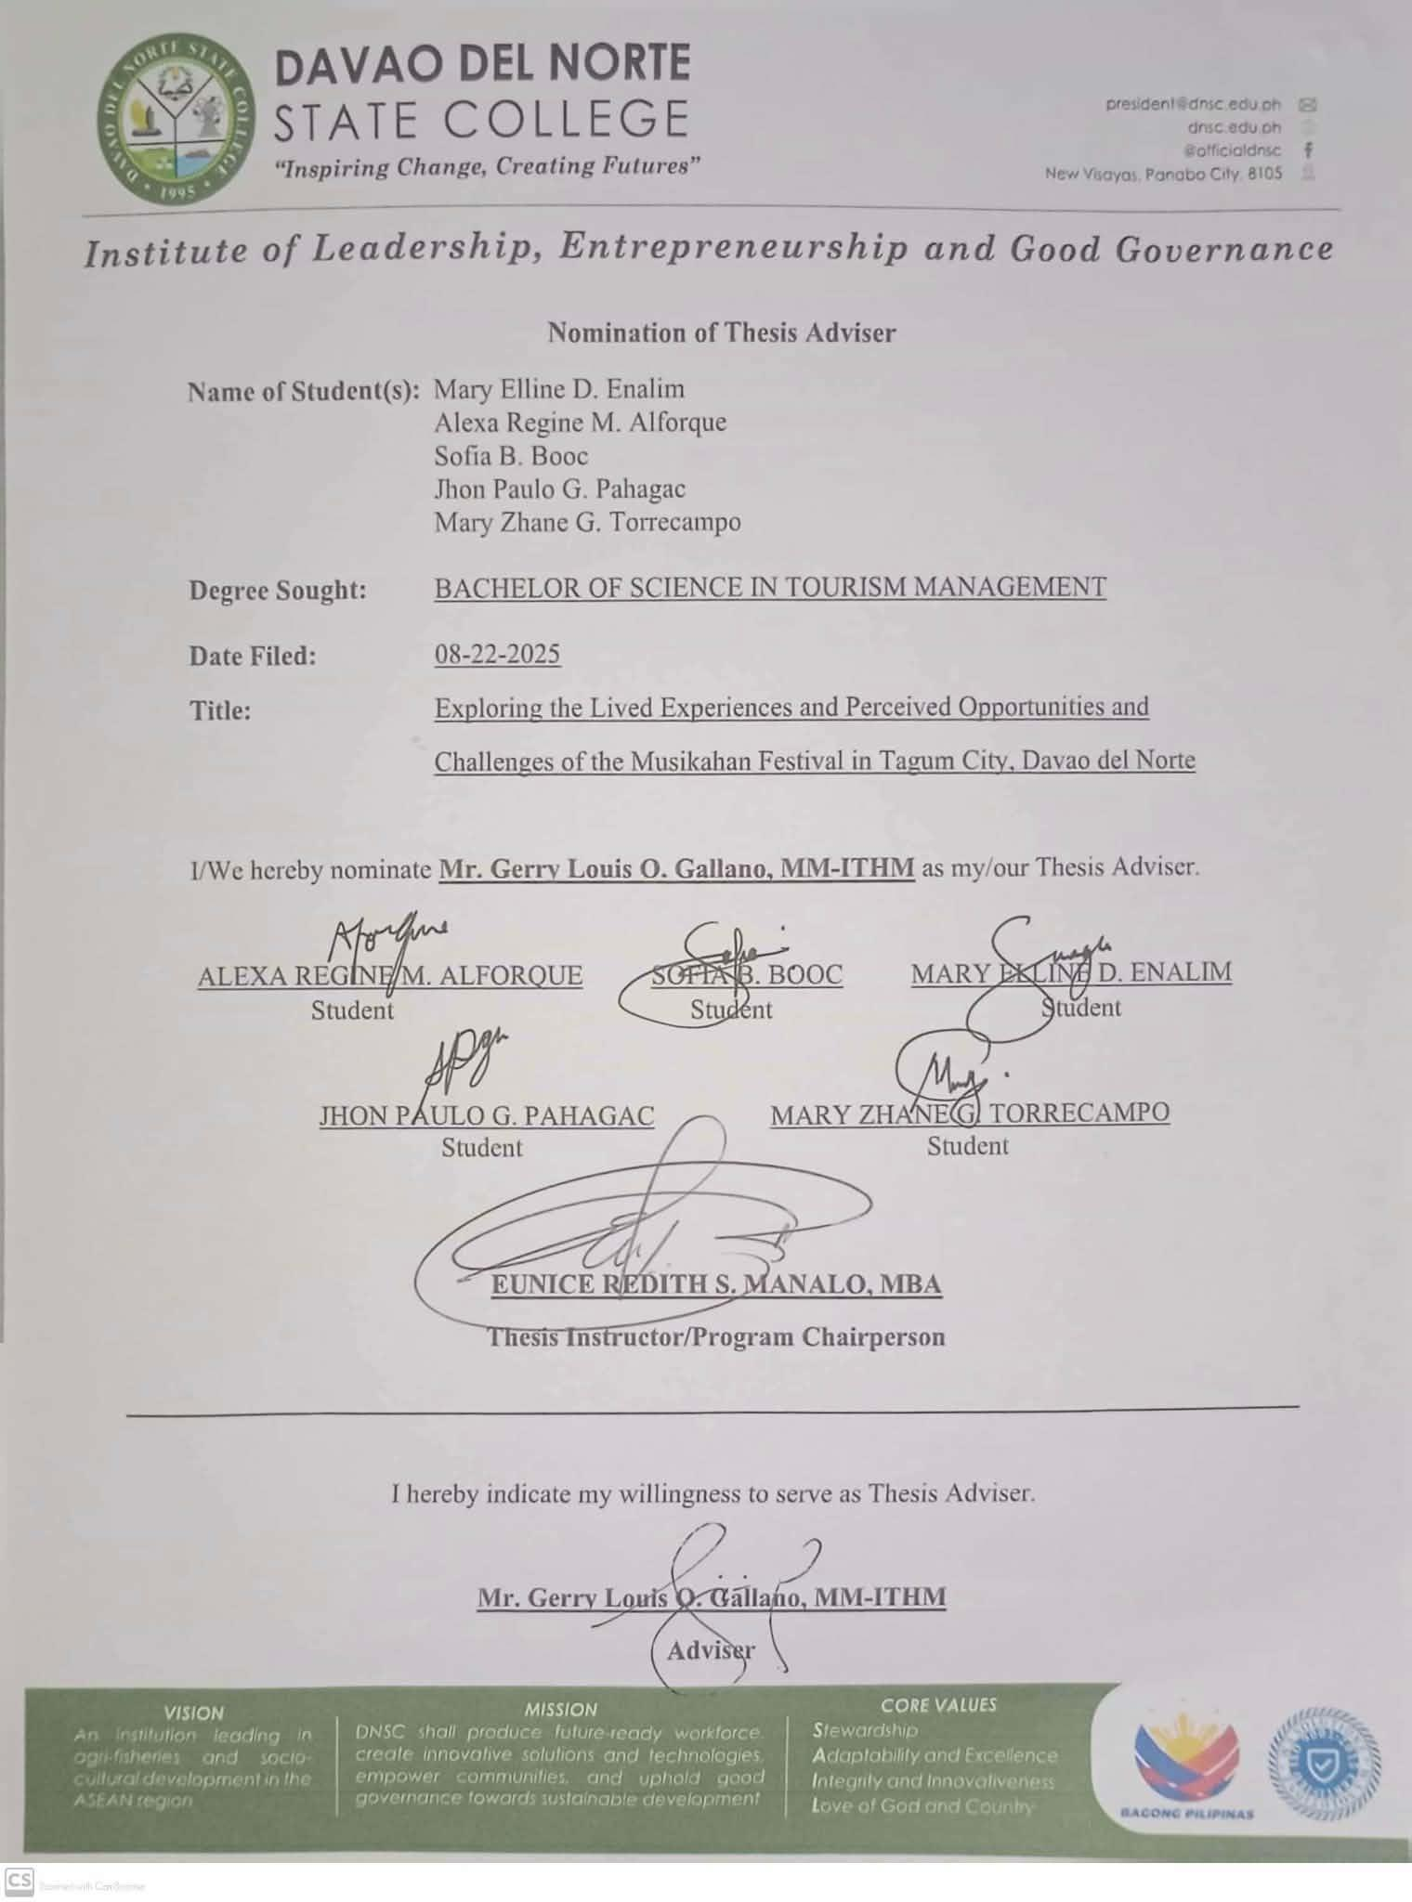

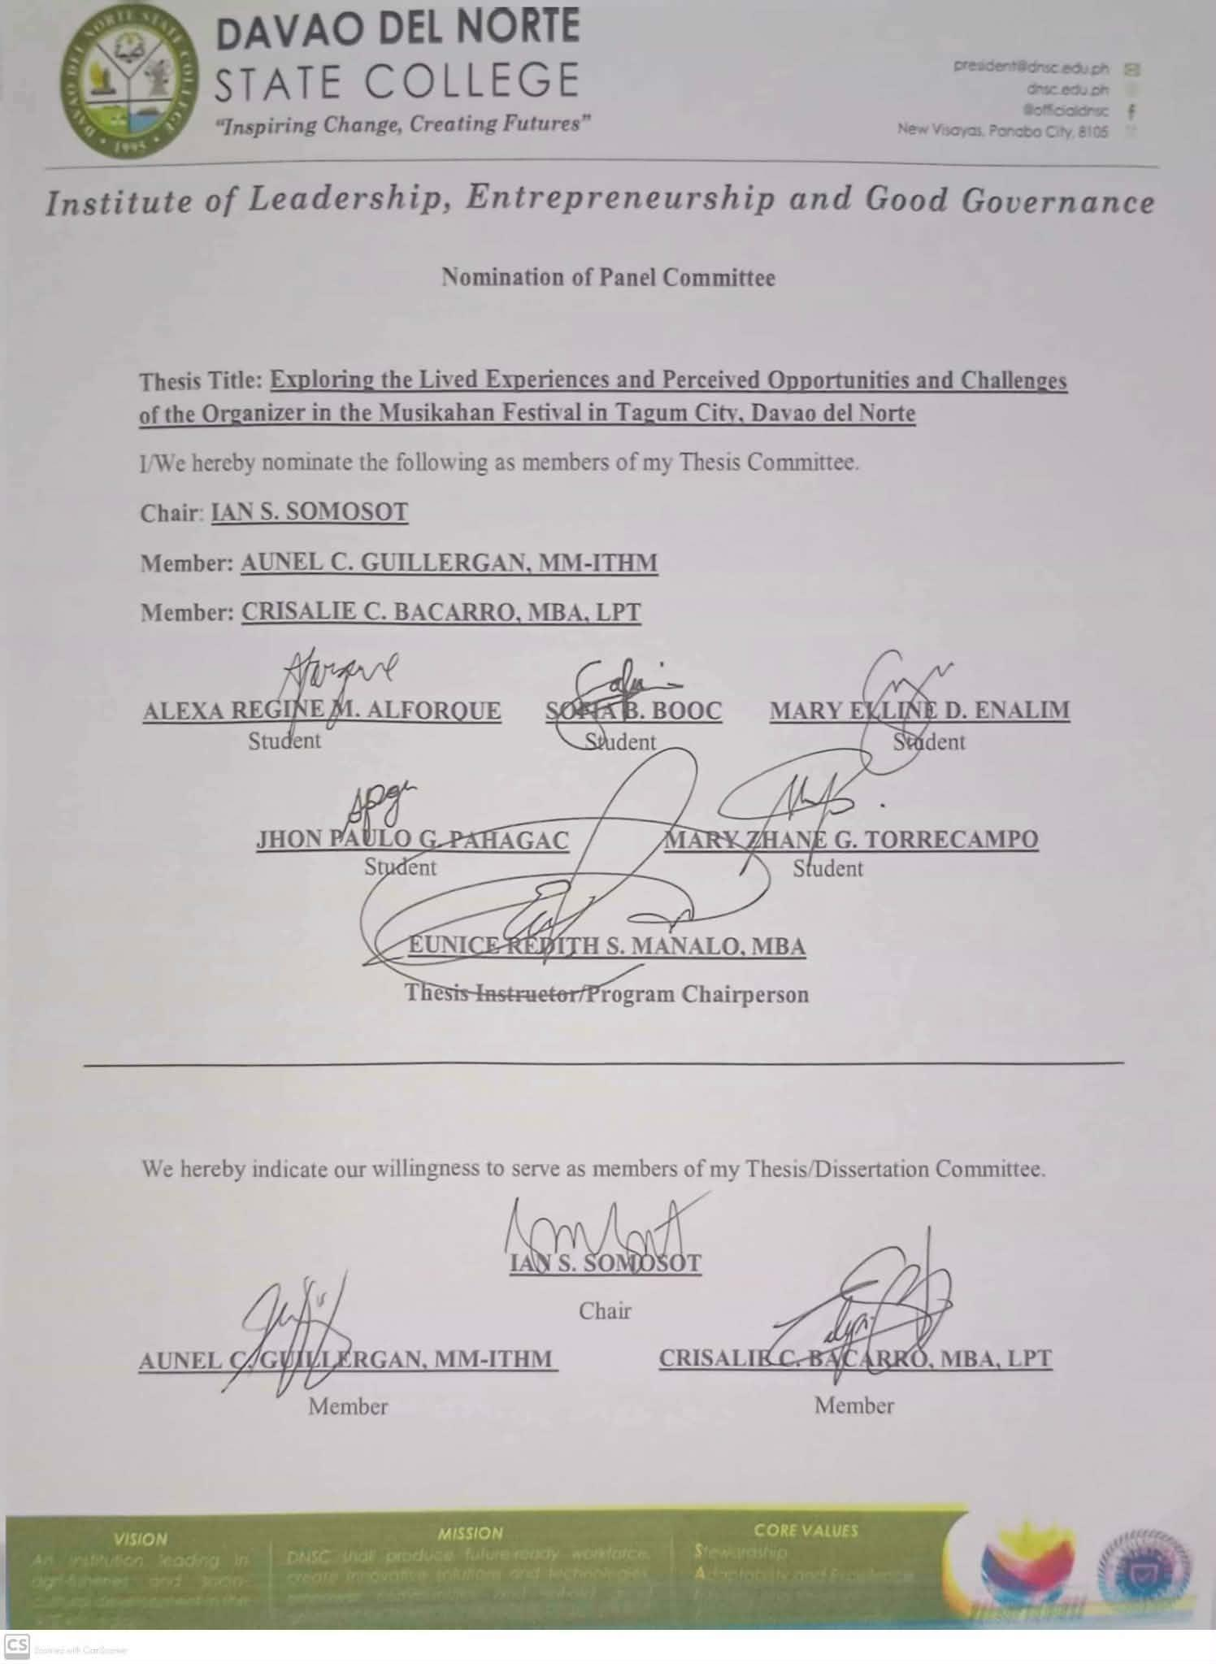

# APPENDIX B

Research Proposal Approval Form

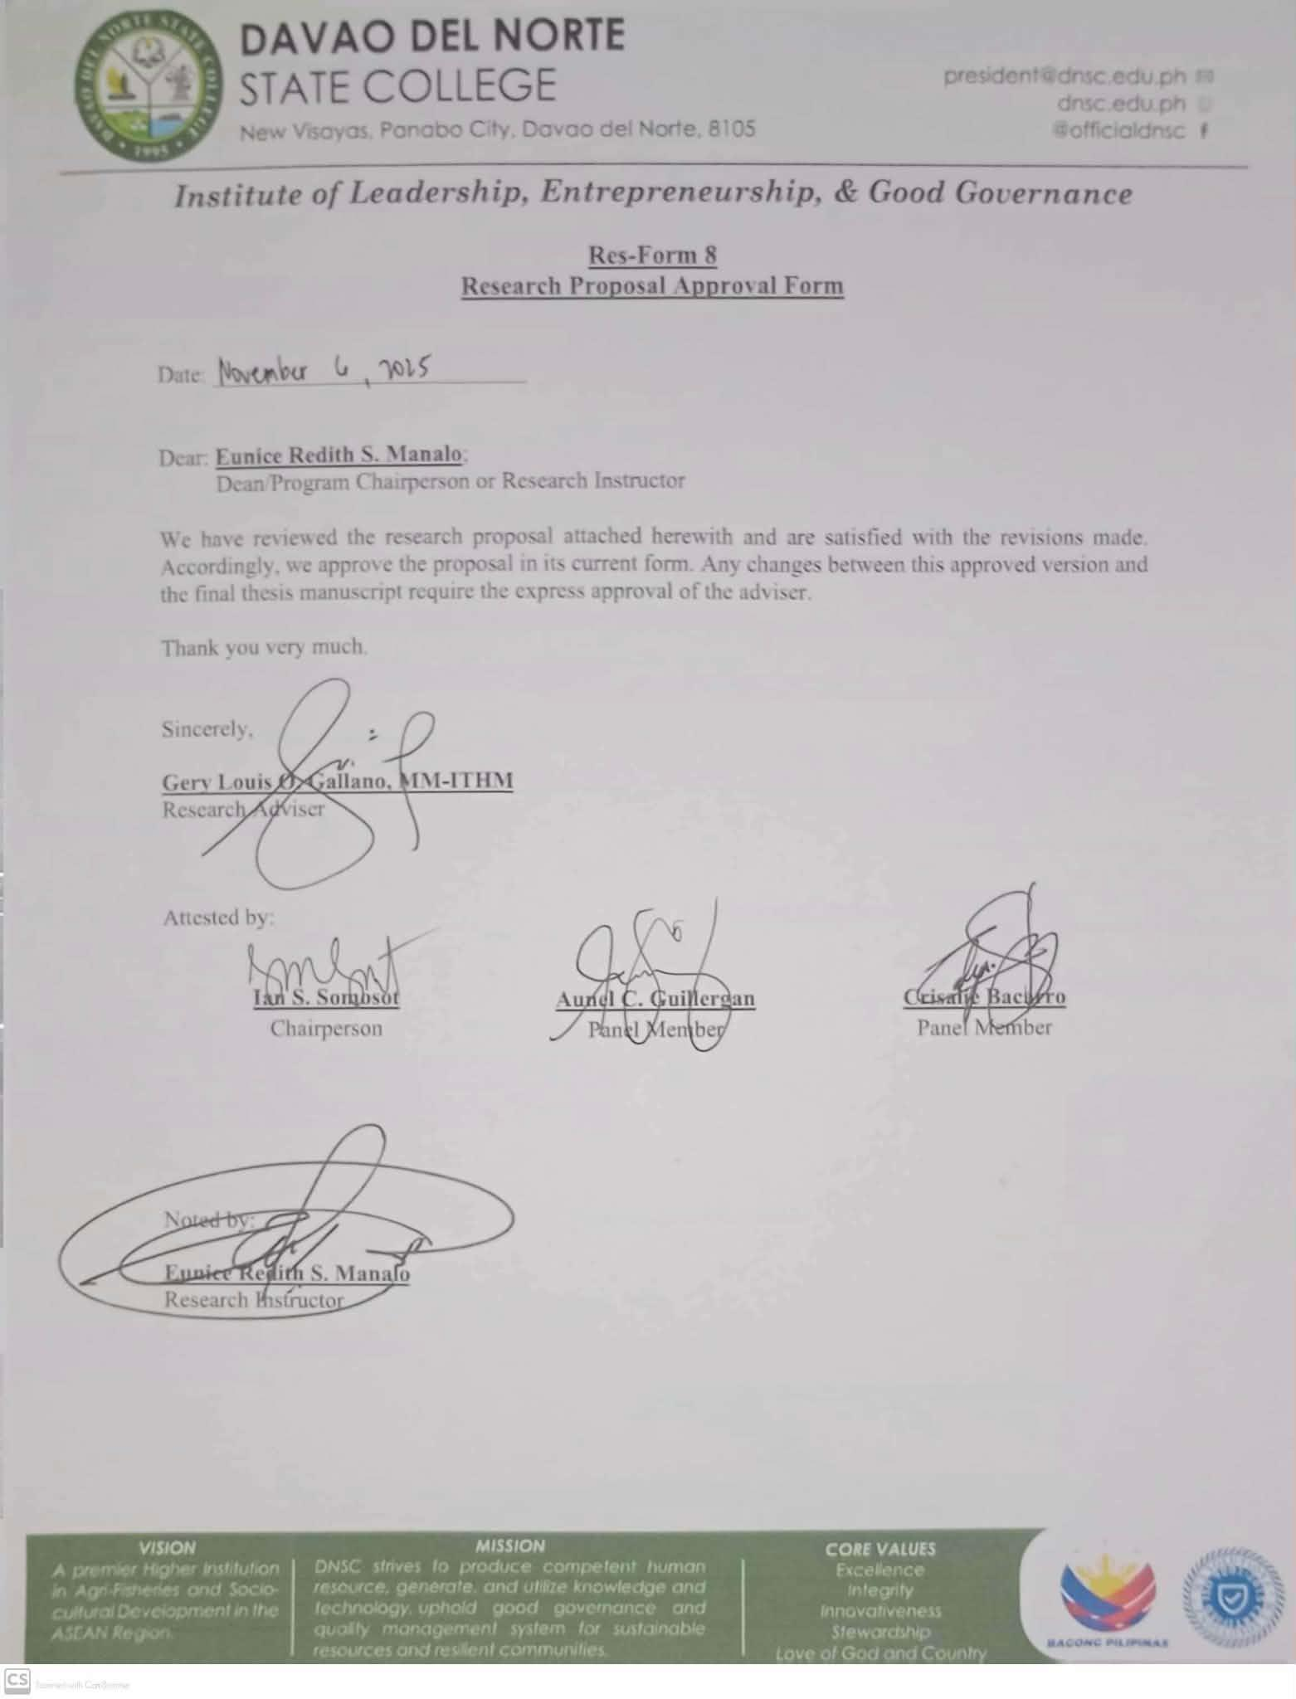

# APPENDIX C

Notice to Commence for Thesis

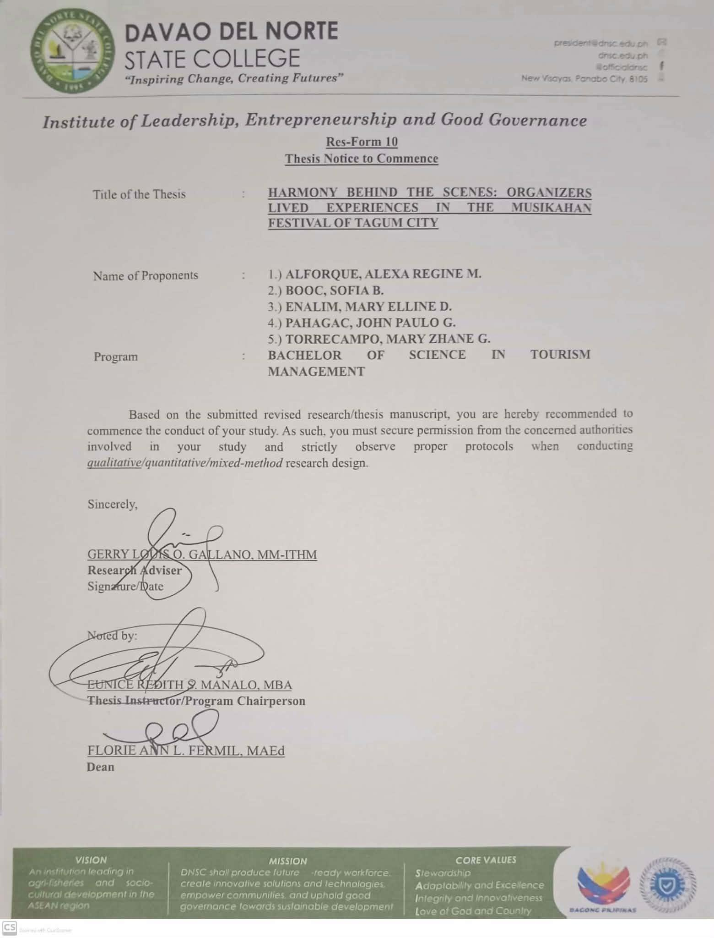

# APPENDIX D

Informed Consent

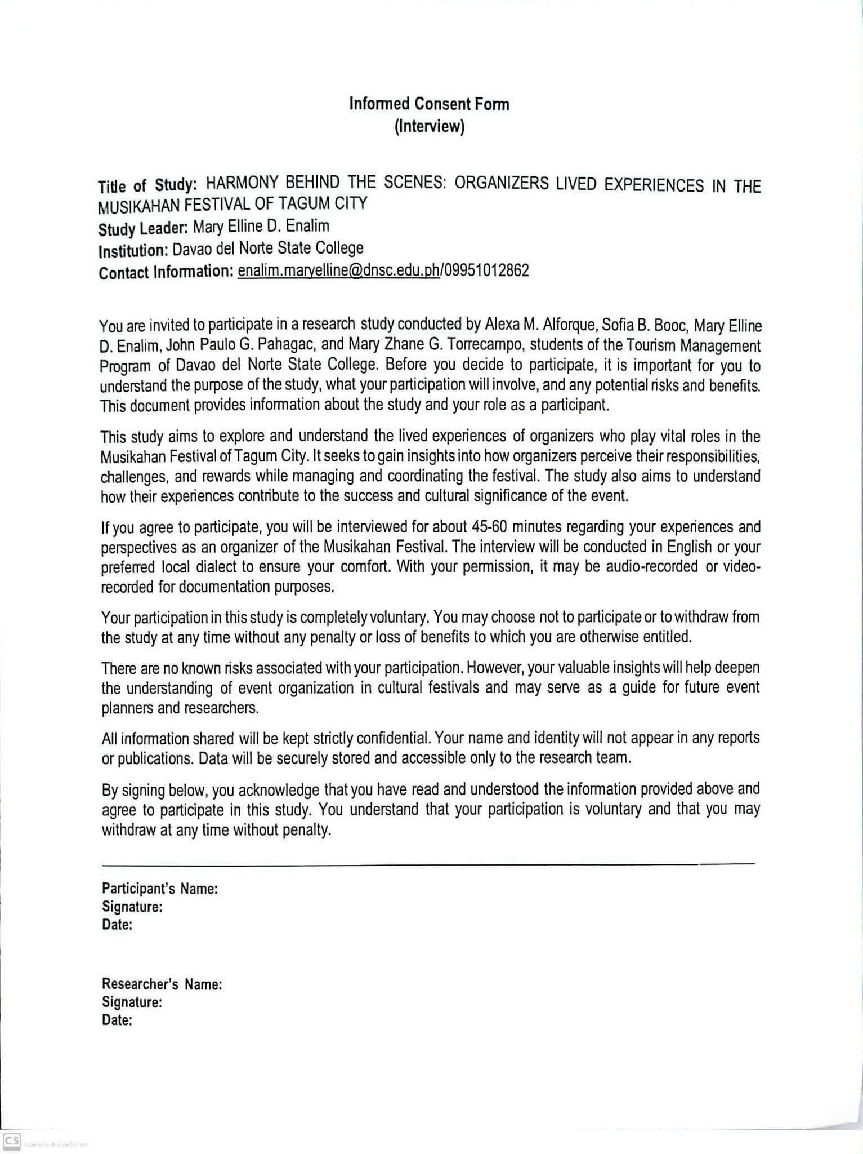

# APPENDIX E

Interview Guide Questions

|  |  |  |
| --- | --- | --- |
| **Research Question (RQ)** | **Interview Questions (IQ)** | **Probing Questions (PQ)** |
| **RQ 1.** What are the lived experiences of the organizers of the Musikahan Festival in Tagum City, particularly in relation to authenticity, inclusivity, and sustainability?  *(Unsa ang mga naangkon nga mga kasinatian sa mga tig- organisa sa Musikahan Festival sa Dakbayan sa Tagum, ilabi na may kalabotan sa mga isyu sa pagka-tinuod, pagkasakop, ug kalikupan?)* | **IQ 1.1:** Reflecting on your involvement, could you describe a significant experience or moment that, for you, best represents what it means to be an organizer of the Musikahan Festival?  *(Sa imong partisipasyon, mahimo ba nimo isaysay ang usa ka hinungdanon nga kasinatian o higayon nga para nimo, labing nagrepresentar kung unsa ang pasabot nga mahimong usa ka tig- organisa sa Musikahan Festival?)* | * Can you share what emotions or thoughts you experienced during that moment?   *(Mahimo ba nimo ipaambit kung unsa ang imong gibati o mga hunahuna niadtong higayona?)*   * What factors made this particular experience stand out?   *(Unsa ang mga hinungdan nga nakapahimo sa maong kasinatian nga talagsaon?)* |
|  |  | * In what ways did this experience influence your perception of the festival?   *(Sa unsang paagi nakaapekto kini nga kasinatian sa imong panan-aw bahin sa festival?)* |
|  | **IQ 1.2:** As an organizer, | * Can you provide an |
| how do you balance the | instance when |
| festival’s commitment to | authenticity and popular |
| cultural authenticity with | appeal were difficult to |
| the need to be inclusive | reconcile? |
| of diverse audiences, | *(Mahimo ba nimo ihatag* |
| while also ensuring its | *ang usa ka pananglitan* |
| long-term sustainability? | *nga lisod pagkahiusa* |
| *(Ingon nga tig-organisa,* | *ang pagka-tinuod ug* |
| *giunsa nimo pagbalanse* | *pagkapopular sa* |
| *ang pagtahud sa tinuod* | *festival?)* |

|  |  |  |
| --- | --- | --- |
|  | *nga kultura sa festival ug ang panginahanglan nga apilon ang nagkalain- laing mga tumatan-aw, samtang masiguro usab ang malungtaron nga pagpadayon niini?)* | * How do you personally define “inclusivity” within the context of the Musikahan Festival? *(Giunsa nimo personal nga paghubad sa “pagkasakop” sa konteksto sa Musikahan Festival?)* * When you think of “sustainability,” what aspects of the festival concern you most? *(Kung maghunahuna ka bahin sa “kalikupan” o “malungtaron nga pagpadayon,” unsang mga aspeto sa festival*   *ang pinaka nagabalaka nimo?)* |
|  | **IQ 1.3:** From your perspective, how has the Musikahan Festival evolved over time in maintaining its cultural roots while adapting to contemporary influences?  *(Gikan sa imong panan- aw, giunsa sa Musikahan Festival ang pag-uswag sa paglabay sa panahon samtang ginaampingan ang kultura niini ug ginatugotan usab nga makaangkon og modernong impluwensya?)* | * What notable changes have you observed in how the festival reflects Tagum City’s culture? *(Unsa ang mga talagsaong kausaban nga imong nabantayan kung giunsa pagrepresentar sa festival ang kultura sa Dakbayan sa Tagum?)* * How do these changes impact the festival’s sense of authenticity? *(Giunsa sa mga kausaban nga kini nakaapekto sa pagka- tinuod sa festival?)* * Do you believe such   adaptations have |

|  |  |  |
| --- | --- | --- |
|  |  | strengthened or challenged the festival’s inclusivity and sustainability? *(Nagatouo ba ka nga kini nga mga pagbag-o nakapalig-on o nakalisod sa pagkasakop ug kalikupan sa festival?)* |
| **RQ 2:** What strategies do the organizers implement to manage the Musikahan Festival in Tagum City?  *(Unsa ang mga pamaagi nga gigamit sa mga tig- organisa aron mapangandaman ug*  *ma-atubang ang komplikadong mga panginahanglan, taas nga lebel sa tensiyon, ug mga panagbangi tali sa mga stakeholders nga nalambigit sa pagdumala sa festival?)* | **IQ 2.1:** The Musikahan Festival can be a high- pressure event. Could you explain the strategies you and your team use to handle logistical challenges and manage stress throughout the process? *(Ang Musikahan Festival usa ka hitabo nga puno sa tensiyon. Mahimo ba nimo ipasabot ang mga pamaagi nga inyong gigamit aron atubangon ang mga hagit sa logistics ug mapangandaman ang stress sa tibuok proseso?)* | * What personal coping mechanisms help you manage pressure during critical periods?   *(Unsa nga mga personal nga pamaagi ang makatabang nimo pagdumala sa pressure sa hinungdanong mga panahon?)*   * Can you recall a time when a logistical plan did not go as expected? How did you respond? *(Mahinumduman ba nimo ang usa ka higayon nga ang plano sa logistics wala miuyon sa gilauman? Giunsa nimo pagtubag niini?)* * Which aspects of festival planning do you find most demanding, and why?   *(Unsa nga mga aspeto sa pagplano sa festival ang pinakalisod para nimo, ug ngano man?)* |
|  | **IQ 2.2:** Given the involvement of various  stakeholders, such as | * What approach did you   use to resolve the disagreement? |

|  |  |  |
| --- | --- | --- |
|  | artists, vendors, the local government, and sponsors, can you describe a situation where you had to manage a conflict or disagreement among these groups?  *(Tungod kay daghang stakeholders ang nalambigit, sama sa mga artista, negosyante, lokal nga gobyerno, ug mga sponsor, mahimo ba nimo isaysay ang usa ka sitwasyon diin kinahanglan nimo pagdumala ang panagbangi tali kanila?)* | *(Unsa nga pamaagi ang imong gigamit aron masulbad ang panagbangi?)*   * How do you ensure effective communication when stakeholders have competing interests? *(Giunsa nimo pagsiguro ang epektibong komunikasyon kung adunay magkalahi nga interes ang mga stakeholders?)* * In your experience, which stakeholder relationship tends to be the most challenging to manage?   *(Sa imong kasinatian, kinsa sa mga stakeholders ang labing lisod pagdumala sa relasyon?)* |
|  | **IQ 2.3:** How do you and your team maintain effective coordination and communication among the different departments or committees involved in organizing the festival? *(Giunsa nimo ug sa imong team pagmintinar sa epektibong koordinasyon ug komunikasyon tali sa nagkalain-laing departamento o komitiba nga nalambigit sa pag- organisa sa festival?)* | * What systems, tools, or practices help keep all teams aligned? *(Unsa nga mga sistema, himan, o pamaagi ang makatabang aron magpabiling magkahiusa ang tanan nga team?)* * Can you describe a situation where strong coordination prevented a potential issue? *(Mahimo ba nimo isaysay ang usa ka*   *sitwasyon diin ang maayo nga* |

|  |  |  |
| --- | --- | --- |
|  |  | *koordinasyon nakapugong sa usa ka posibleng problema?)*   * What communication challenges typically arise, and how do you address them?   *(Unsa ang kasagarang mga hagit sa*  *komunikasyon ug giunsa ninyo kini pag-atubang?)* |
| **RQ 3:** What insights have the organizers gained from their involvement, and what recommendations do they propose for enhancing operational harmony and long-term sustainability?  *(Unsa ang mga panan- aw o mga pagtulun-an nga nakuha sa mga organizer gikan sa ilang pag-apil, ug unsa ang ilang mga sugyot aron mapauswag ang kahapsay sa pagdumala ug ang malungtarong kalamboan sa umaabot?)* | **IQ 3.1:** Over the years of your involvement, what major insights have you gained, and how has this experience shaped your understanding of the festival and Tagum City’s cultural identity? *(Sa mga katuigan sa imong partisipasyon, unsang mga dagkong leksyon ang imong nakuha, ug giunsa niini paghulma ang imong pagsabot sa festival ug sa kultural nga identidad sa Dakbayan sa Tagum?)* | * What do you understand now that you did not at the beginning of your involvement? *(Unsa ang imong nasabtan karon nga wala nimo masabti sa sinugdanan sa imong pag-apil?)* * What common misconceptions do you think people have about the role of festival organizers?   *(Unsa ang kasagaran nga sayop nga pagtuo sa mga tawo bahin sa papel sa mga tig- organisa sa festival?)*   * How has this experience personally influenced your professional or cultural outlook?   *(Giunsa niini nga kasinatian pag- impluwensya sa imong*  *personal nga panan-aw sa propesyon o kultura?)* |

|  |  |  |
| --- | --- | --- |
|  | **IQ 3.2:** Based on your experiences, what recommendations would you offer to future organizers to promote operational harmony and ensure the festival’s  long-term sustainability? *(Base sa imong mga kasinatian, unsa nga mga sugyot ang imong ikahatag sa mga umaabot nga tig- organisa aron mapaayo ang panaghiusa ug masiguro ang malungtaron nga kalamboan sa festival?)* | * If you could change one aspect to make organizing more efficient, what would it be?   *(Kung pwede nimo usbon ang usa ka aspeto aron mahimong mas epektibo ang pag- organisa, unsa kini?)*   * In your opinion, what is the greatest threat to the festival’s continued success?   *(Sa imong opinyon, unsa ang pinakadakong hulga sa padayong kalampusan sa festival?)*   * What practical steps can be taken to strengthen organizational collaboration and sustainability?   *(Unsa nga praktikal nga mga lakang ang mahimo aron mapalig-on ang kolaborasyon ug kalikupan sa organisasyon?)* |
|  | **IQ 3.3:** Looking ahead, how do you envision the Musikahan Festival evolving over the next decade?  *(Sa umaabot nga mga tuig, giunsa nimo pagtan-aw ang pag- uswag sa Musikahan*  *Festival sa mosunod nga dekada?)* | * What trends or transformations do you foresee in its organization or audience engagement?   *(Unsa nga mga uso o kausaban ang imong makita nga mahitabo sa pag-organisa o*  *partisipasyon sa mga tumatan-aw?)* |

|  |  |  |
| --- | --- | --- |
|  |  | * How might future organizers anticipate and address emerging challenges?   *(Giunsa sa mga umaabot nga tig- organisa pagtagna ug pag-atubang sa mga umaabot nga hagit?)*   * What legacy do you hope the festival will leave for Tagum City’s cultural identity? *(Unsa nga panulondon ang gusto nimo nga*   *ibilin sa festival para sa kultural nga identidad sa Dakbayan sa Tagum?)* |

# APPENDIX F

Validation Forms

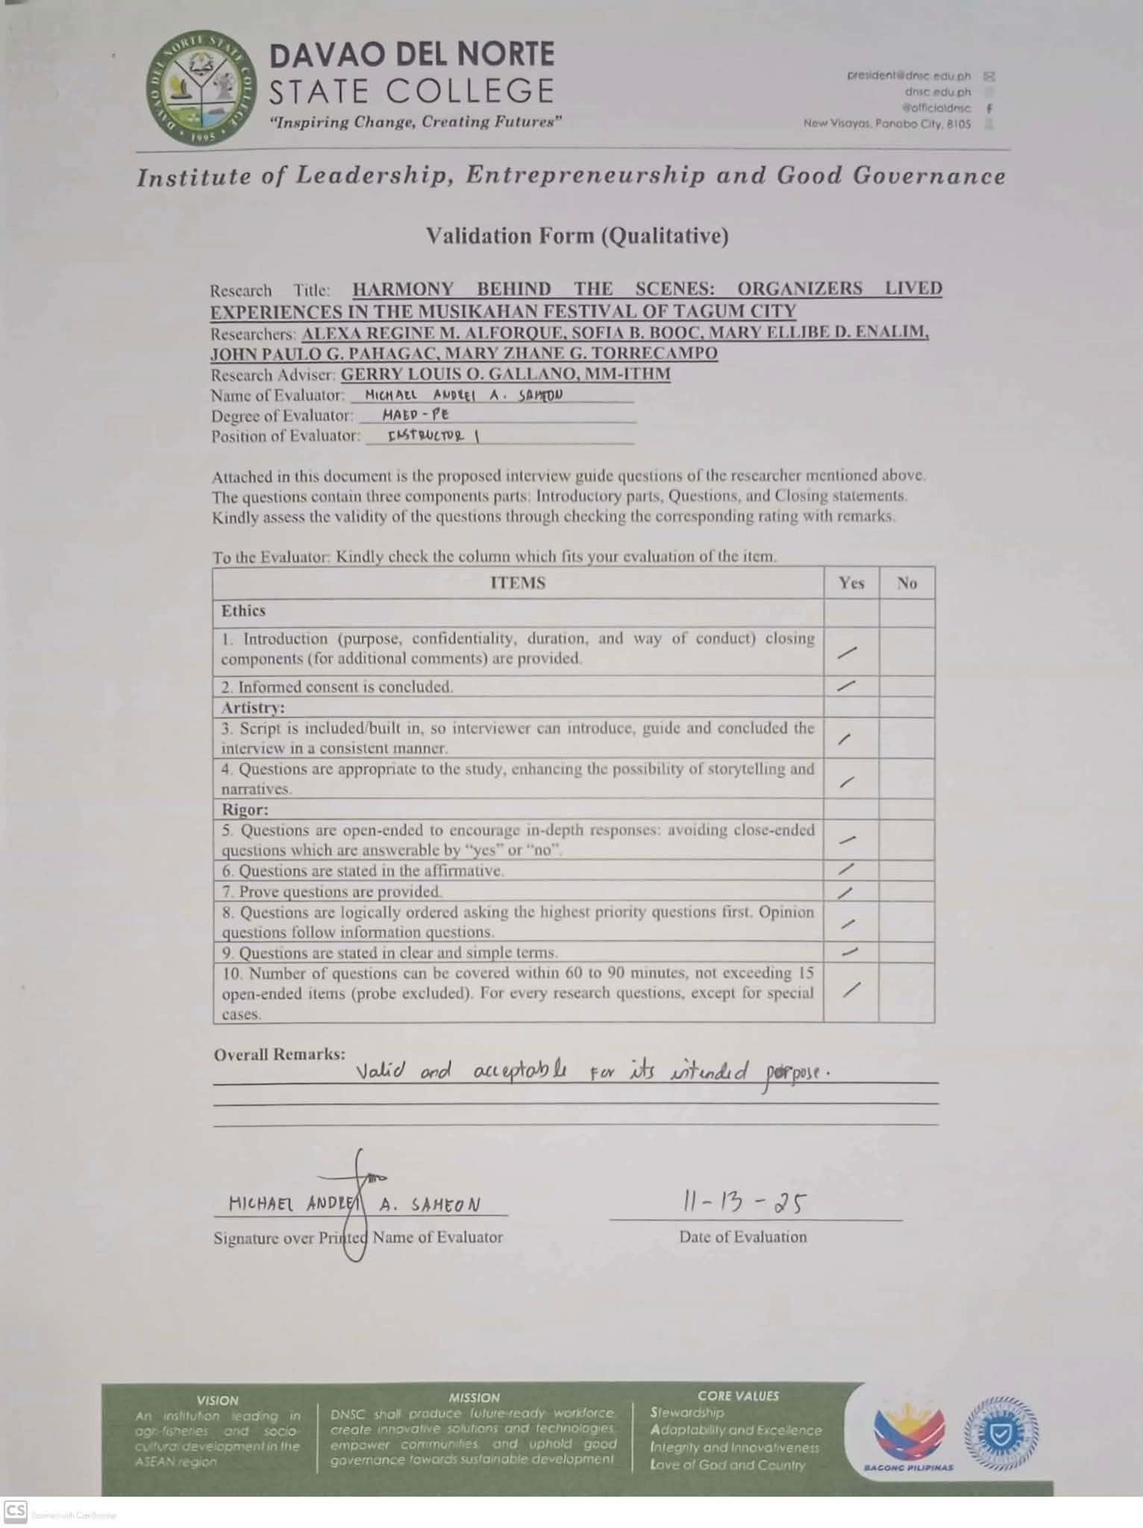

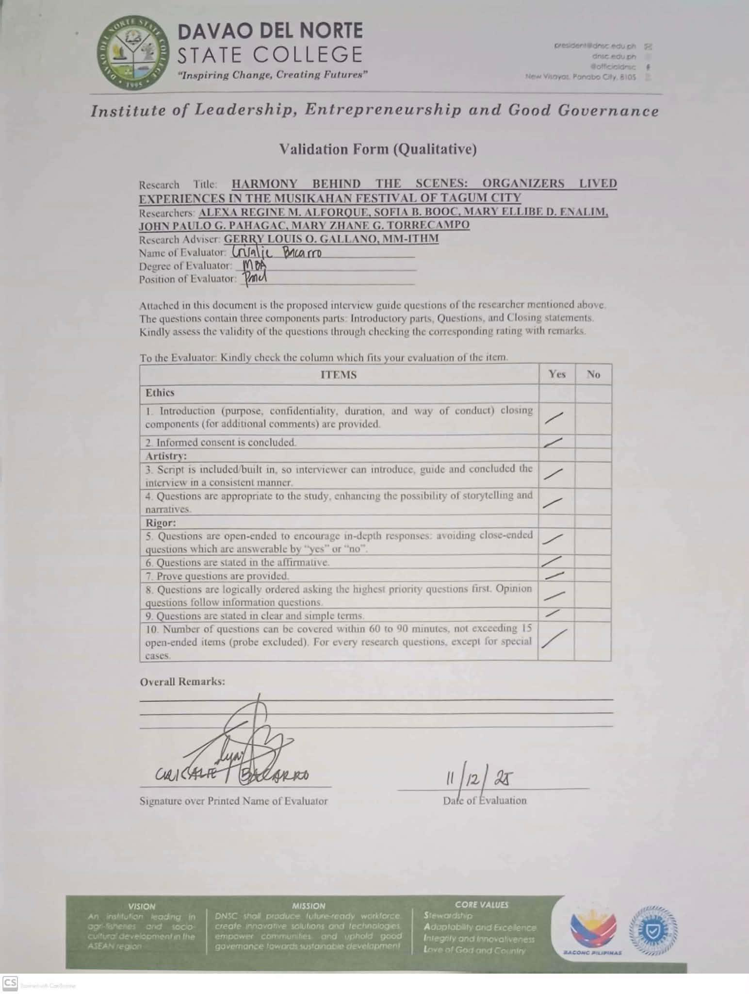

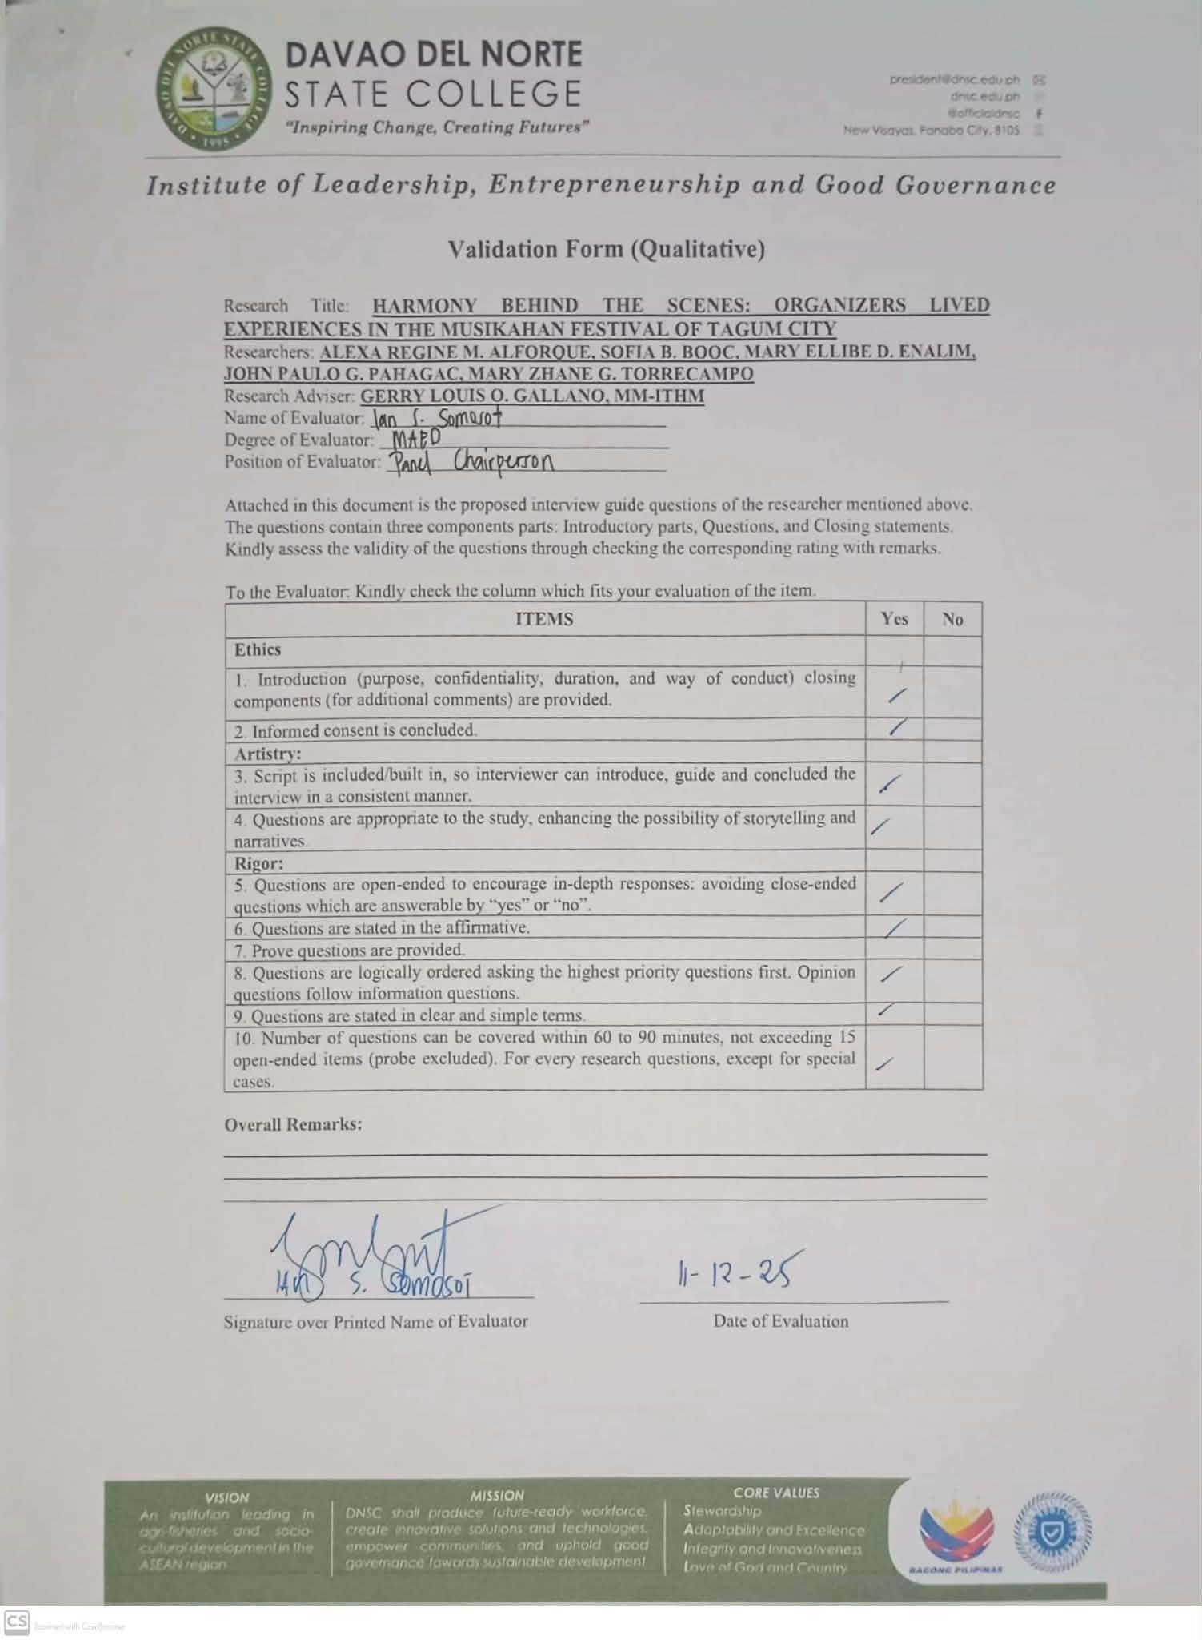

# APPENDIX G

Research Approval Form

# APPENDIX H

Certificate of Grammarian

# APPENDIX I

Plagiarism Report

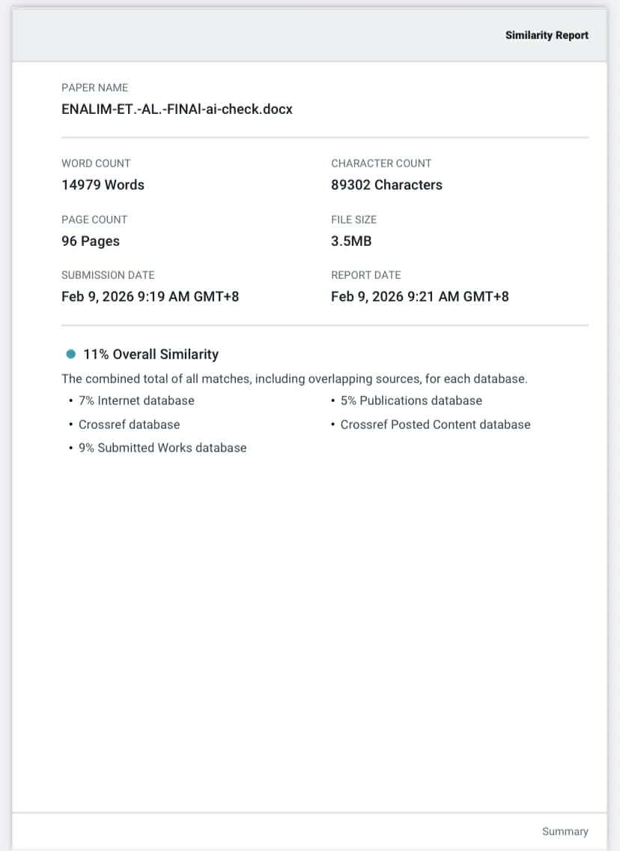

# APPENDIX J

Letter to Conduct

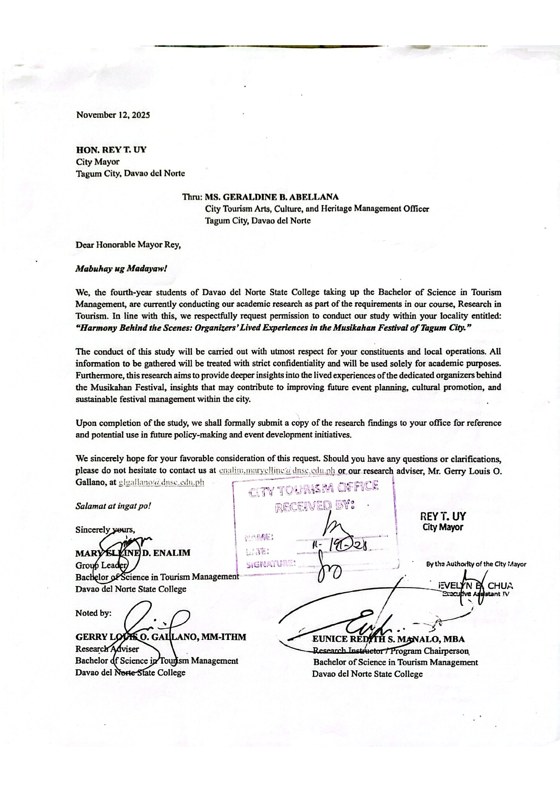

# APPENDIX K

Documentation

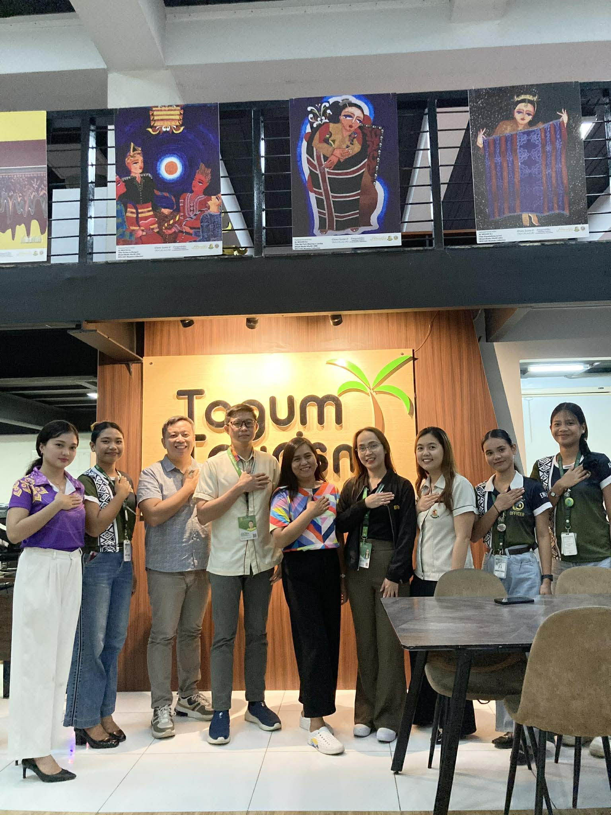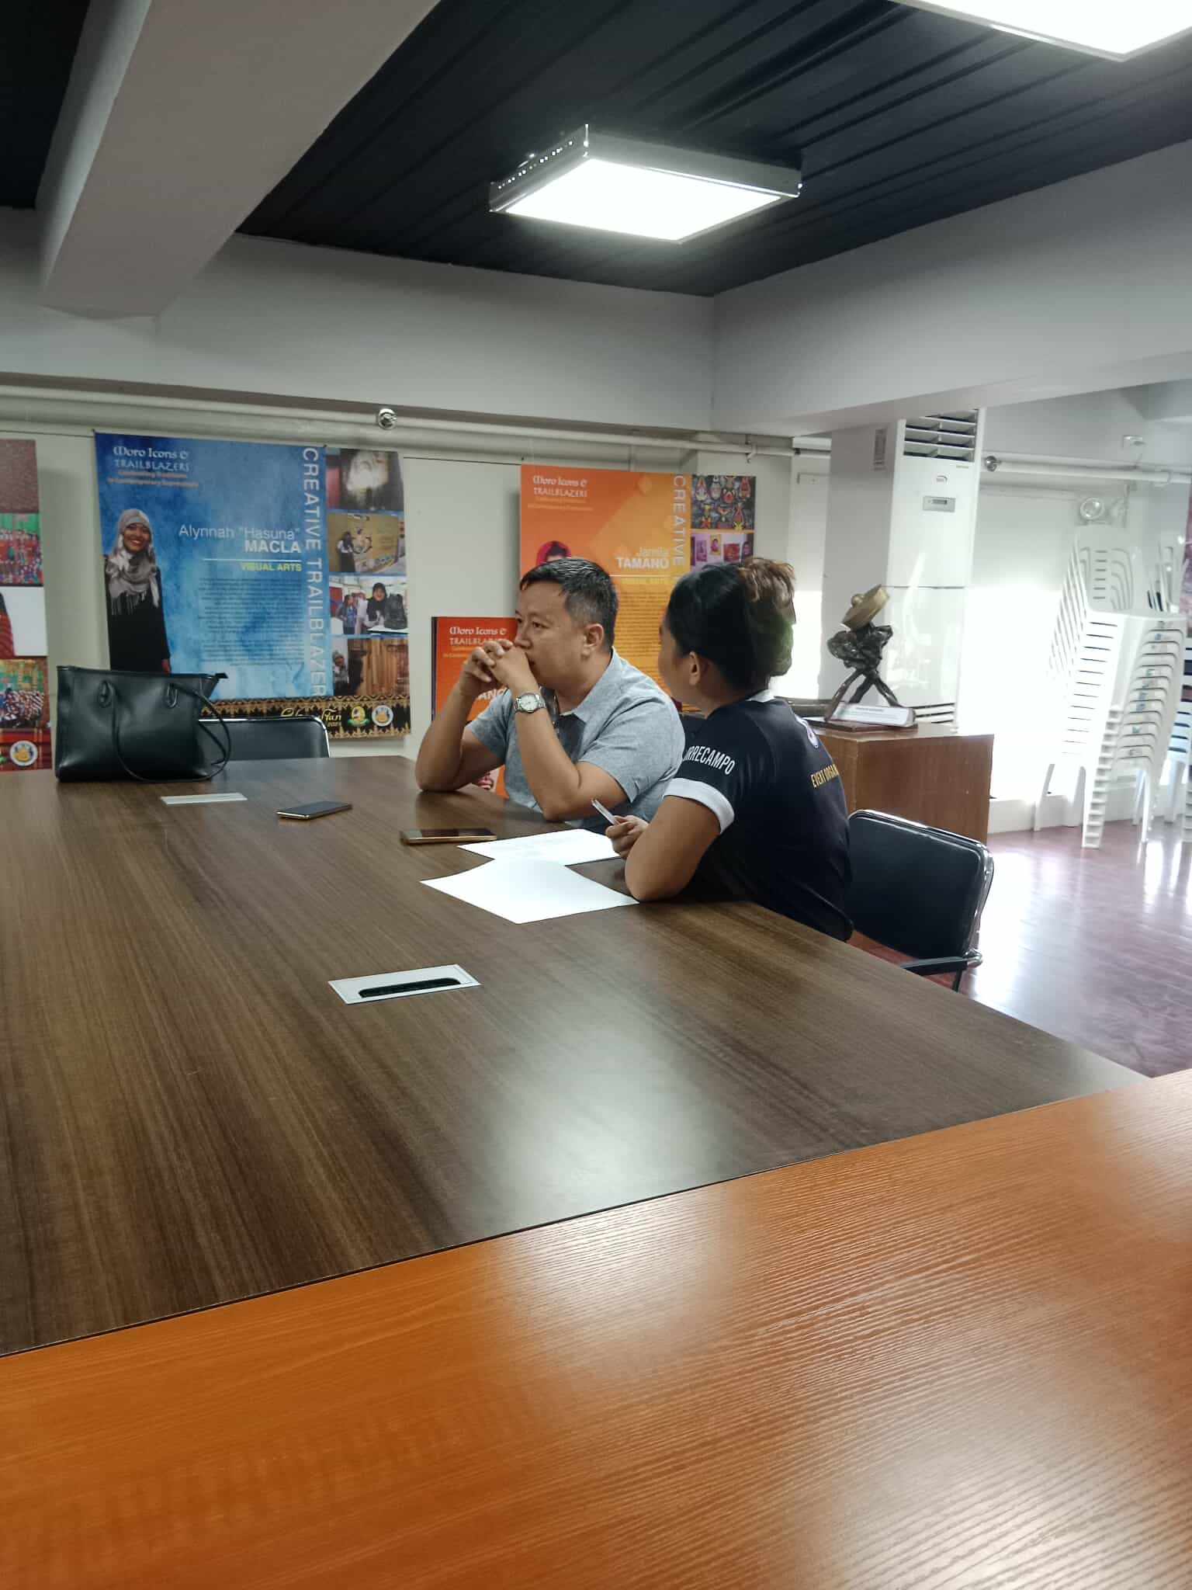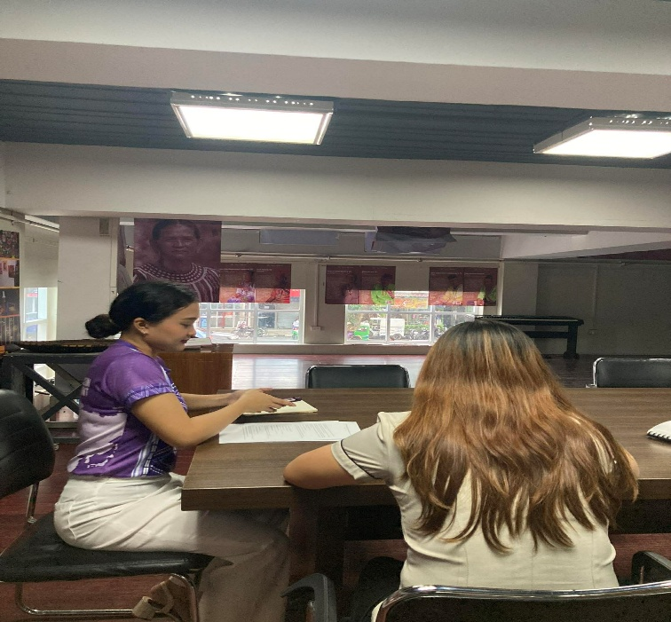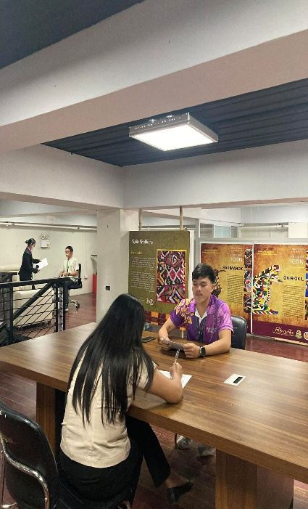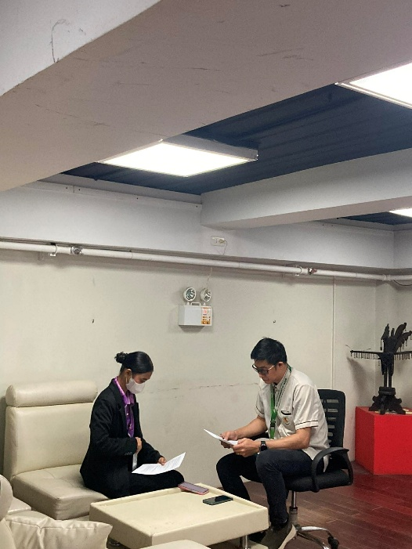

# APPENDIX L

Curriculum Vitae

**ALEXA REGINE M. ALFORQUE**

ADDRESS : Prk. Libra Tambongon, Lasang, Davao City

MOBILE NO. : 0995 610 2672

EMAIL : alforque.alexaregine@dnsc.edu.ph

**PERSONAL DATA**

BIRTHDATE : March 26, 2004

AGE : 21

HEIGHT : 164 cm

WEIGHT : 50 kg

RELIGION : Roman Catholic

CIVIL STATUS : Single

NATIONALITY : Filipino

FATHER’S NAME : Mario Joel C. Alforque

MOTHER’S NAME : Marishelle M. Alforque

**EDUCATION BACKGROUND**

TERTIARY : **Davao del Norte State College**

Bachelor of Science in Tourism Management  
 2022 - Present

SECONDARY : **A.L Navarro National High School**

Graduated Year 2020

**Gabriel Taborin College of Davao Foundation Inc.**

Graduated Year 2022

ELEMENTARY :  **Tambongon Elementary School**

Graduated Year 2016

**TRAINNINGS AND SEMINARS**

* Bridging Theory & Practice Gaining Insights from Industry Expert – March 2025
* Guide to Safety: Basic First Aid – Bandaging Training – April 2025
* How to Ace: Delve to Media Literacy in Academic Writing and Public Speaking – May 2024
* Cultural Mapping Workshop – October 2024
* Job Readiness: Professional Development Seminar – April 2025
* Filipino Brand Service of Excellence Seminar – Workship – June 2025
* Research in Tourism: Data Collection, Data Analysis, and Writing the Results – November 2025
* Skills Clinic: Housekeeping and Event Hosting Seminar and Workshop – November 2025
* Empowering the Workforce: Labor Laws, Fair Compensation, and Respectful Workplace in Tourism and Hospitality – November 2025

**EXTRA-CURRICULAR AND ORGANIZATIONAL AFFILIATIONS**

* Tourism Socio-Cultural Chamber Member, UFTS-DNC Chapter (2024-2025)

**CERTIFICATIONS AND EXAMINATION PASSED**

* SABRE Functionalities for Tourism Students – Certificate of Competency – January 2025
* Events Management Services NC III – May 2025
* Fron Office Services NC II – October 2025
* Professional Hotel Front Office Course (PHFOC) – October 2025

**SOFIA B. BOOC**

ADDRESS :Purok 17, Hilltop, Bunawan, Davao City

MOBILE NO. :0908-715-9728

EMAIL :booc.sofia@dnsc.edu.ph

**PERSONAL DATA**

BIRTHDATE : March 5, 2004

AGE : 21

HEIGHT : 160 cm

WEIGHT : 52 kg.

RELIGION : Roman Catholic

CIVIL STATUS : Single

NATIONALITY : Filipino

FATHER’S NAME : Cecilio D. Booc Jr.

MOTHER’S NAME : Adelin B. Booc

**EDUCATION BACKGROUND**

**TERTIARY** : **Davao del Norte State College**

Bachelor of Science in Tourism Management  
 2022 – Present

**SECONDARY** : **Northlink Technological College Inc.**

Graduated Year 2022

**ELEMENTARY** : **Daniel M. Perez Elementary School Sped Center**

Graduated Year 2016

**TRAININGS AND SEMINARS**

* Operations Management Seminar - 2024
* Bridging Traditions Mapping our Cultural Heritage for a Sustainable Future - 2024
* Basic Computer Literacy Course - September 2024
* Guide to Safety: Basic First Aid- Bandaging Training - 2004
* Skills Bridging Traditions: Mapping our Cultural Heritage for a Sustainable Future - October 2024
* Building Theory and Practice Gaining Strategic Insights from an Industry Expert- March 2025
* Branding Training Future Proof of Your Career Mastering Job Readiness- April 2025
* Professional Lecture for Legal Aspects in Tourism and Hospitality TMC4112 - 2025
* Event Hosting Seminar and Workshop - 2025
* Housekeeping Seminar and Workshop - 2025
* Research in Tourism: Data Collection, Data Analysis, and Writing the Results - 2025
* Future Proof of Your Career Mastering Job Readiness Skills - 2025
* Community Tour Guiding – September 2025
* Basic Photography – September 2025
* Content Script Writing and Social Media Etiquette – September 2025
* Filipino Brand of Service Excellence (FBSE) – September 2025
* Basic First Aid Training – September 2025
* Philippine History/Folklore (Local History and Culture) – September 2025
* Duties and Responsibilities of a Tour Guide and Practical Guiding Techniques – September 2025
* Tour Script Preparation and Presentation/Techniques – September 2025

**CERTIFICATIONS AND EXAMINATION PASSED**

* SABRE Functionalities for Tourism Students – Certificate of Competency – January 2025
* Events Management Services NC III – November 2025
* Front Office Services NC II – December 2025
* Professional Hotel Front Office Course (PHFOC) – October 2025
* TEFL Certification (March 2025)– September 2025

**MARY ELLINE D. ENALIM**

ADDRESS :Purok 3, Alejal, Carmen, Davao del Norte

MOBILE NO. :0995-101-2862

EMAIL :enalim.maryelline@dnsc.edu.ph

**PERSONAL DATA**

BIRTHDATE : September 24, 2003

AGE : 22

HEIGHT : 153 cm

WEIGHT : 43 kg.

RELIGION : Roman Catholic

CIVIL STATUS : Single

NATIONALITY : Filipino

FATHER’S NAME : Romeo T. Enalim Sr.

MOTHER’S NAME : Imelda D. Enalim

**EDUCATION BACKGROUND**

**TERTIARY** : **Davao del Norte State College**

Bachelor of Science in Tourism Management  
 2022 – Present

**SECONDARY** : **Carmen National High School**

Graduated Year 2022

**ELEMENTARY** : **Alejal Elementary School**

Graduated Year 2016

**TRAININGS AND SEMINARS**

* Basic Tour Guiding Workshop – August 2023
* Southern Mindanao Summit: Tourism & Green Investment – December 2023
* Guide to Safety: Basic First Aid and Bandaging Training – April 2024
* How to Ace: Delve to Media Literacy in Academic Writing and Public Speaking – May 2024
* Community Tour Guiding Training – August 2024
* Cultural Mapping Workshop – October 2024
* Job Readiness: Professional Development Seminar - April 2025
* Filipino Brand of Service Excellence Training - June 2025
* Research in Tourism: Data Collection, Data Analysis, and Writing the Results - November 2025
* Skills Clinic: Housekeeping and Event Hosting Seminar and Workshop - November 2025
* Empowering the Workforce: Labor Laws, Fair Compensation, and Respectful Workplaces in Tourism and Hospitality - November 2025

**EXTRA-CURRICULAR AND ORGANIZATIONAL AFFILIATIONS**

* Secretary, UFTS-DNSC Chapter (2023-2024)
* Tourism Chamber Events Guild Coordinator, UFTS-DNSC Chapter (2023-2024)
* Assistant Secretary, UFTS-DNSC Chapter (2024-2025)
* Internal Vice President, Sundaya Productions (2025)

**CERTIFICATIONS AND EXAMINATION PASSED**

* DOT-Accredited Community Tour Guide - August 2024
* SABRE Functionalities for Tourism Students - Certificate of Competency - January 2025
* Events Management Services NC III - August 2025
* Front Office Services NC II - November 2025
* Professional Hotel Front Office Course (PHFOC) - October 2025

**MARY ZHANE G. TORRECAMPO**

ADDRESS : Purok 2, GK Dacudao, Tibungco,

Davao City

MOBILE NO. : 0956-816-2753

EMAIL : torrecampo.maryzhane@dnsc.edu.ph

**PERSONAL DATA**

BIRTHDATE : December 24, 2004

AGE : 21

HEIGHT : 160 cm

WEIGHT : 57 kg.

RELIGION : Christian

CIVIL STATUS : Single

NATIONALITY : Filipino

FATHER’S NAME : Arnold M. Torrecampo

MOTHER’S NAME : Rubylyn G. Torrecampo

**EDUCATION BACKGROUND**

**TERTIARY** : **Davao del Norte State College**

Bachelor of Science in Tourism Management  
 2022 – Present

**SECONDARY** : **UM-Ilang High School**

Graduated Year 2022

**ELEMENTARY** : **F. Bustamante Elementary School**

Graduated Year 2016

**TRAININGS AND SEMINARS**

* Operations Management Seminar (2024)
* Bridging Traditions Mapping our Cultural Heritage for a Sustainable Future (2024)
* Basic Computer Literacy Course- September 2024 –
* Guide to Safety: Basic First Aid- Bandaging Training (2004)
* Skills Bridging Traditions: Mapping our Cultural Heritage for a Sustainable Future- October 2024
* Building Theory and Practice Gaining Strategic Insights from an Industry Expert- March 2025
* Branding Training Future Proof of Your Career Mastering Job Readiness- April 2025
* Professional Lecture for Legal Aspects in Tourism and Hospitality TMC4112 (2025)
* Event Hosting Seminar and Workshop (2025)
* Housekeeping Seminar and Workshop (2025)
* Research in Tourism: Data Collection, Data Analysis, and Writing the Results (2025)
* Future Proof of Your Career Mastering Job Readiness Skills (2025)

**CERTIFICATIONS AND EXAMINATION PASSED**

* SABRE Functionalities for Tourism Students - Certificate of Competency - January 2025
* Events Management Services NC III - November 2025
* Front Office Services NC II - December 2025
* Professional Hotel Front Office Course (PHFOC) - October 2025